**Project**

**Title:** Deployment of Mediplus Website using IIS, Application Gateway and multi-factor Authentication services.

**Group Members:**

1. Nupur Mahajan
2. Sairaj Musale
3. Saurav Karande

**IIS Service:**

IIS stands for **Internet Information Services**is a flexible, general-purpose [web server](https://www.techtarget.com/whatis/definition/Web-server) from Microsoft that runs on Windows systems to serve requested [HTML](https://www.theserverside.com/definition/HTML-Hypertext-Markup-Language) pages or files.

An IIS web server accepts requests from remote client computers and returns the appropriate response. This basic functionality allows web servers to share and deliver information across local area networks ([LAN](https://www.techtarget.com/searchnetworking/definition/local-area-network-LAN)), such as corporate intranets, and wide area networks ([WAN](https://www.techtarget.com/searchnetworking/definition/WAN-wide-area-network)), such as the Internet.

A web server can deliver information to users in several forms, such as static webpages coded in HTML; through file exchanges as downloads and uploads; and text documents, image files and more.

**Application Gateway:**

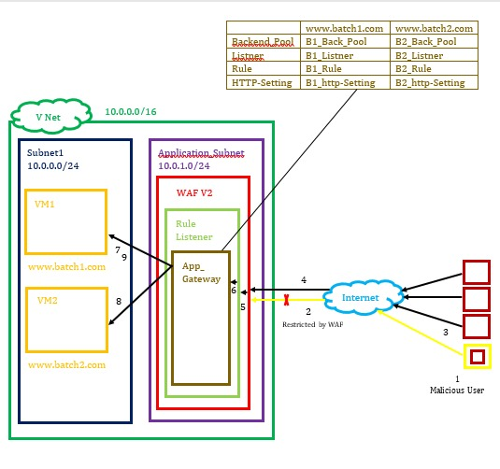

In a V-Net there are two subnets such as Subnet1 and Application-subnet.

In Subnet1 there are two VM such as VM1 & VM2. VM1 contains a website

In Application-subnet there is App_Gateway. Application Gateway work like a Load balancer for multi website to distributes the internet traffic equally towards the healthy server (VM1 or VM2).

An App_Gateway is covered with a rule listener. A rule listener defines the rule such as Port 80 has arrived and to which VM it should it go.

WAF V2 Web Application Firewall is used here due to the security propose. As it blocks the Malicious users. If WAF allows the users to come insides then only the rule is defined.

If the users goes on the internet. The internet traffic is forwarded to WAF which checks if any of the user is malicious then it will block it or else forward the traffic towards the App_Gateway.

As App_Gateway receives the traffic the rule will be assigned by the Rule Listener. As per the rule the App_Gateway will transfer the traffic equally on VM1 & on VM2 as for the need of the user which website is required.

**Multi-factor Authentication (MFA):**

MFA is a second level of security to the users.

From Active Directory we can assign the authentication to user.

User 1

User 4

Admin

(Root)

User 3

User 2

Suppose there is admin and multiple users.

If any user forget the pasword then he/she will go to admin and then can reset the password.

But if many users forget the password then all user have to go to admin which will increase burden on the admin.

So to tackle this problem self service password reset is the solution

By self service password reset the user can reset the password without ging to admin.

**Step 1:** Create Virtual Network

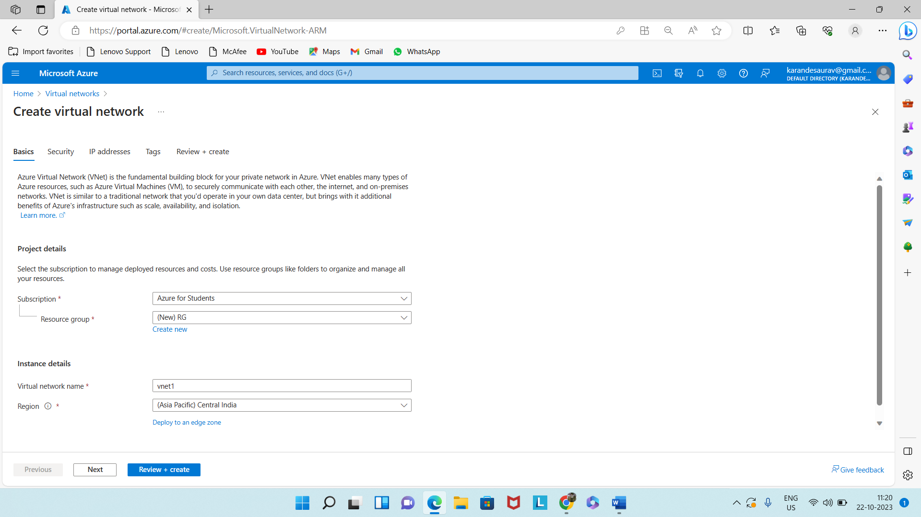

**Step 2:** Create a two Subnets. One Subnet use to Virtual Machines and One Subnet use to Application gateways.

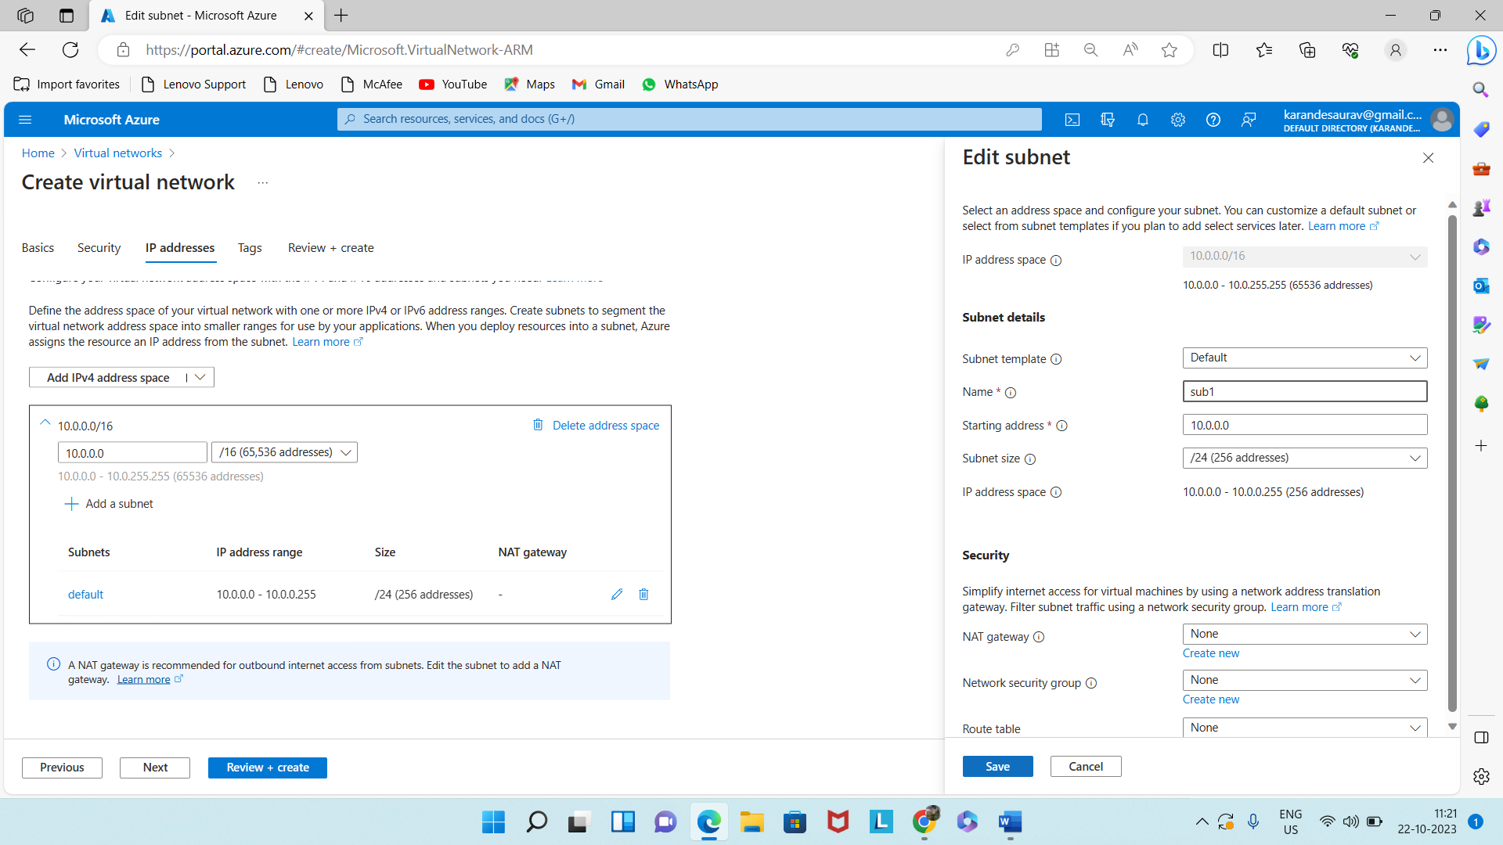

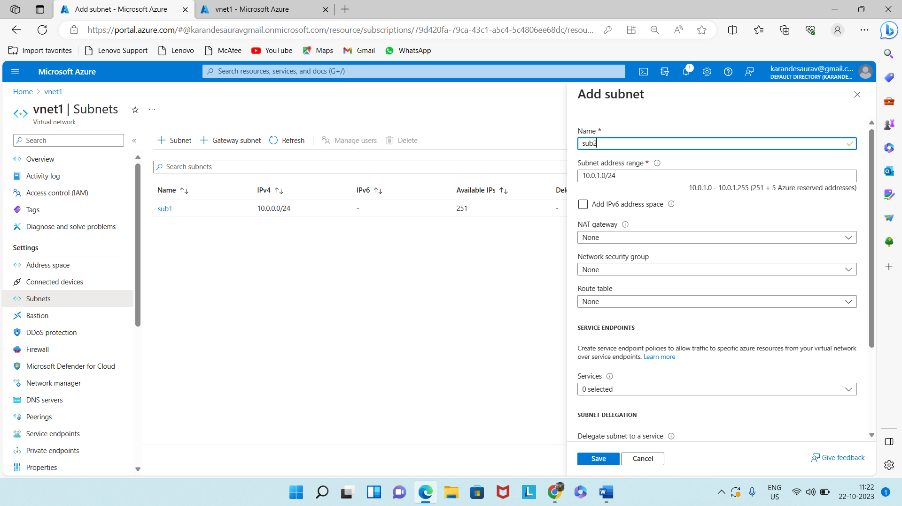

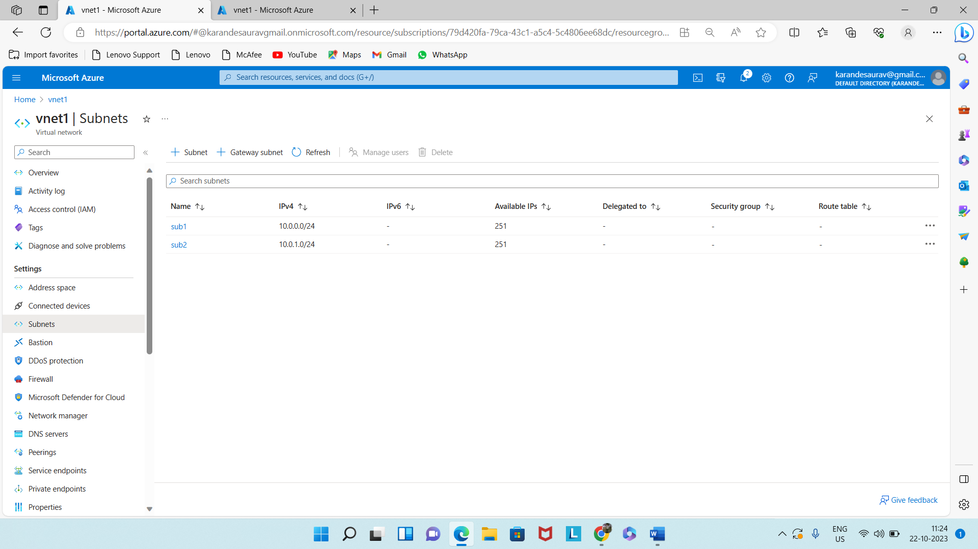

**Step 3:** Create 2 virtual machines.

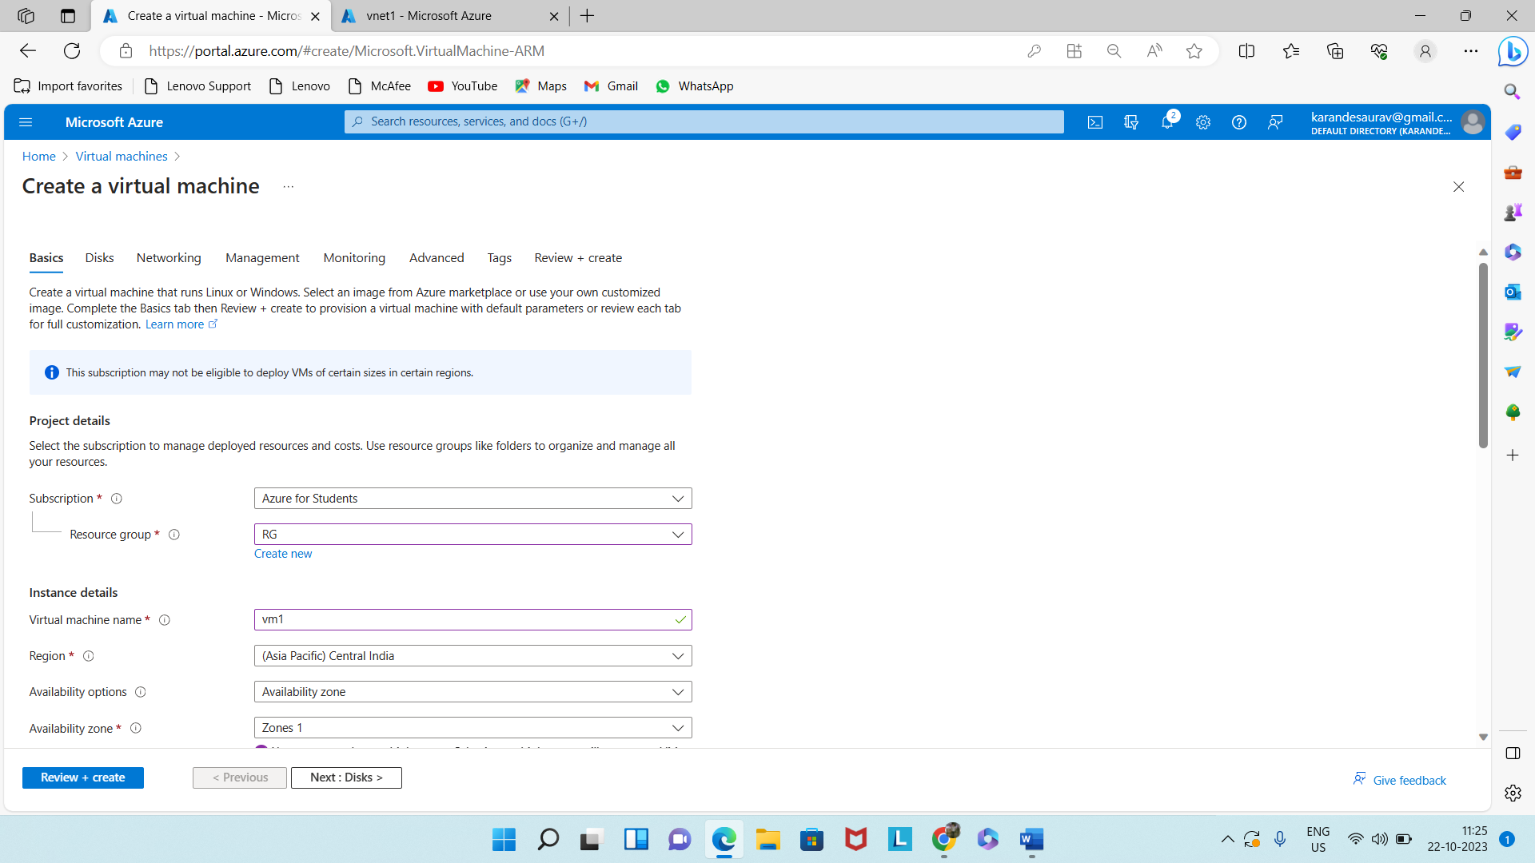

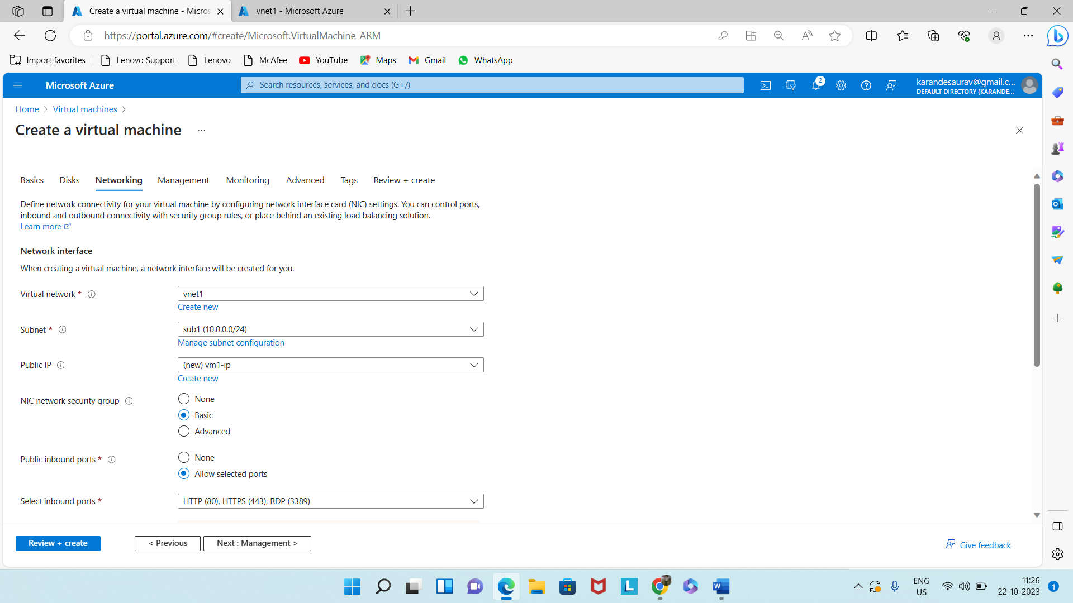

Now connect 1st VM

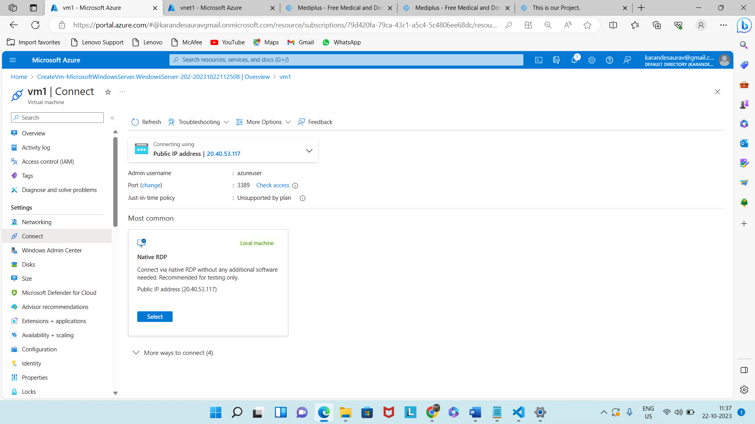

Install IIS in 1st VM

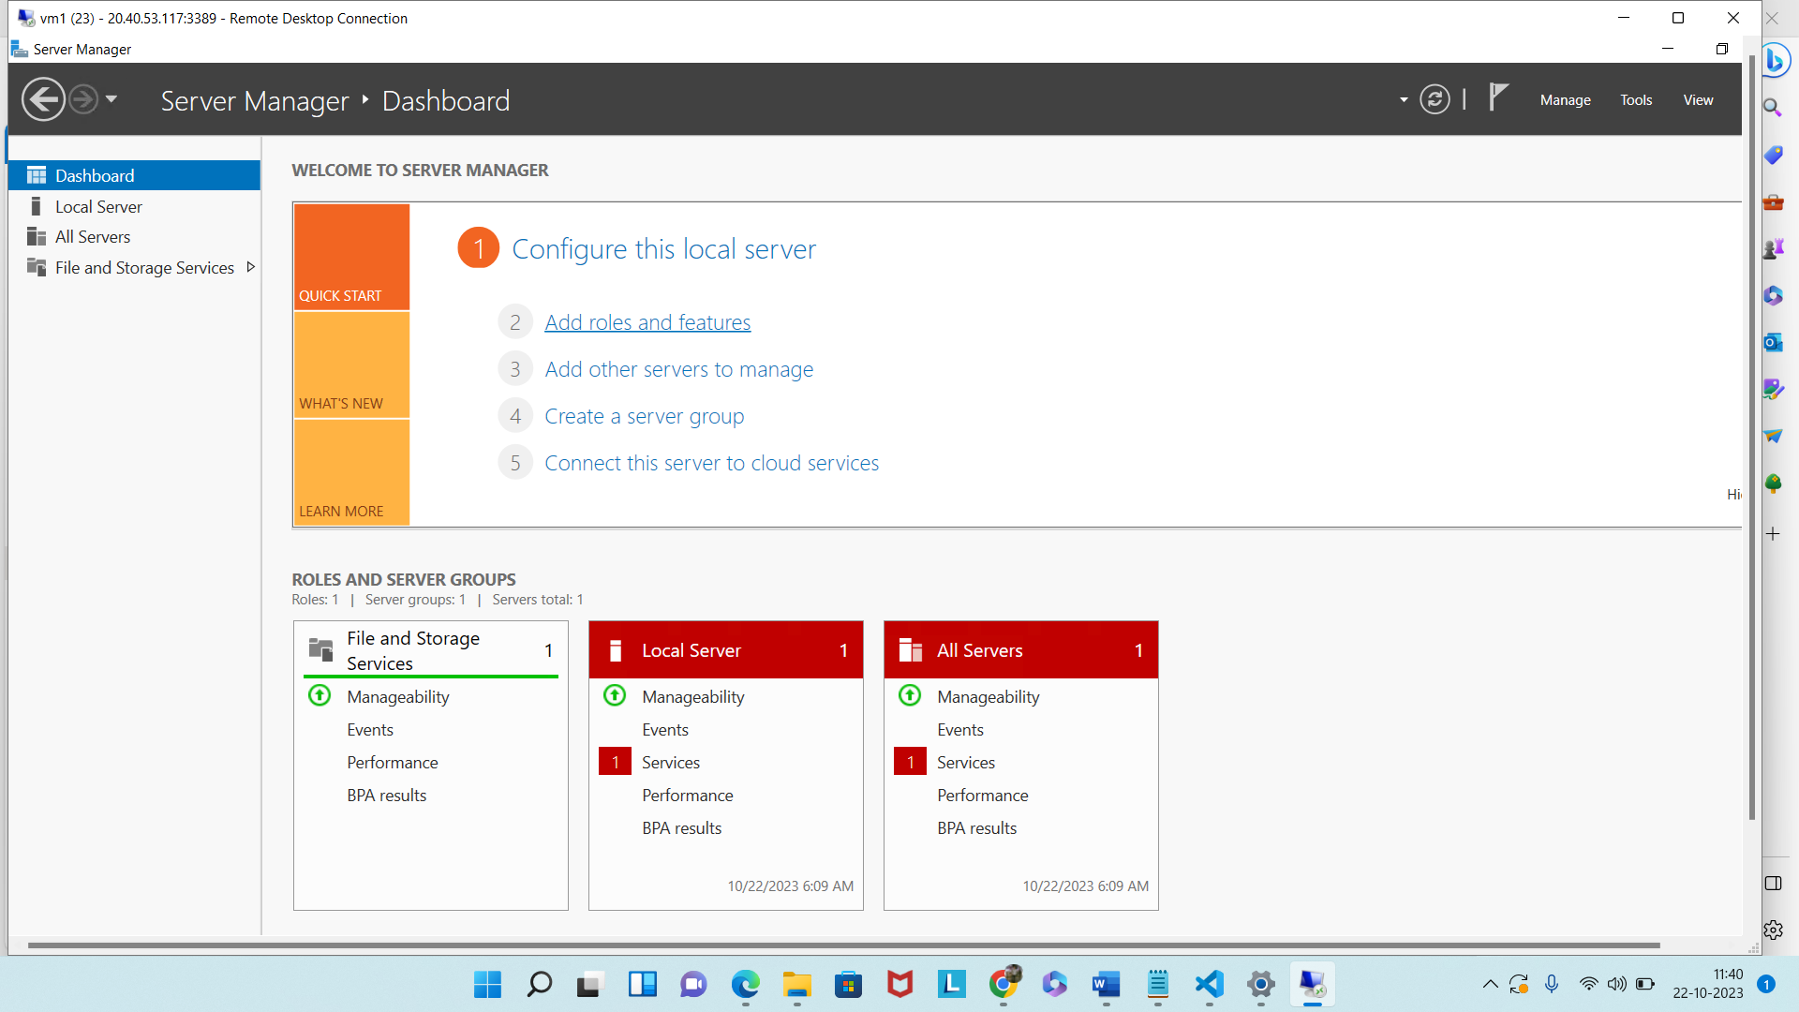

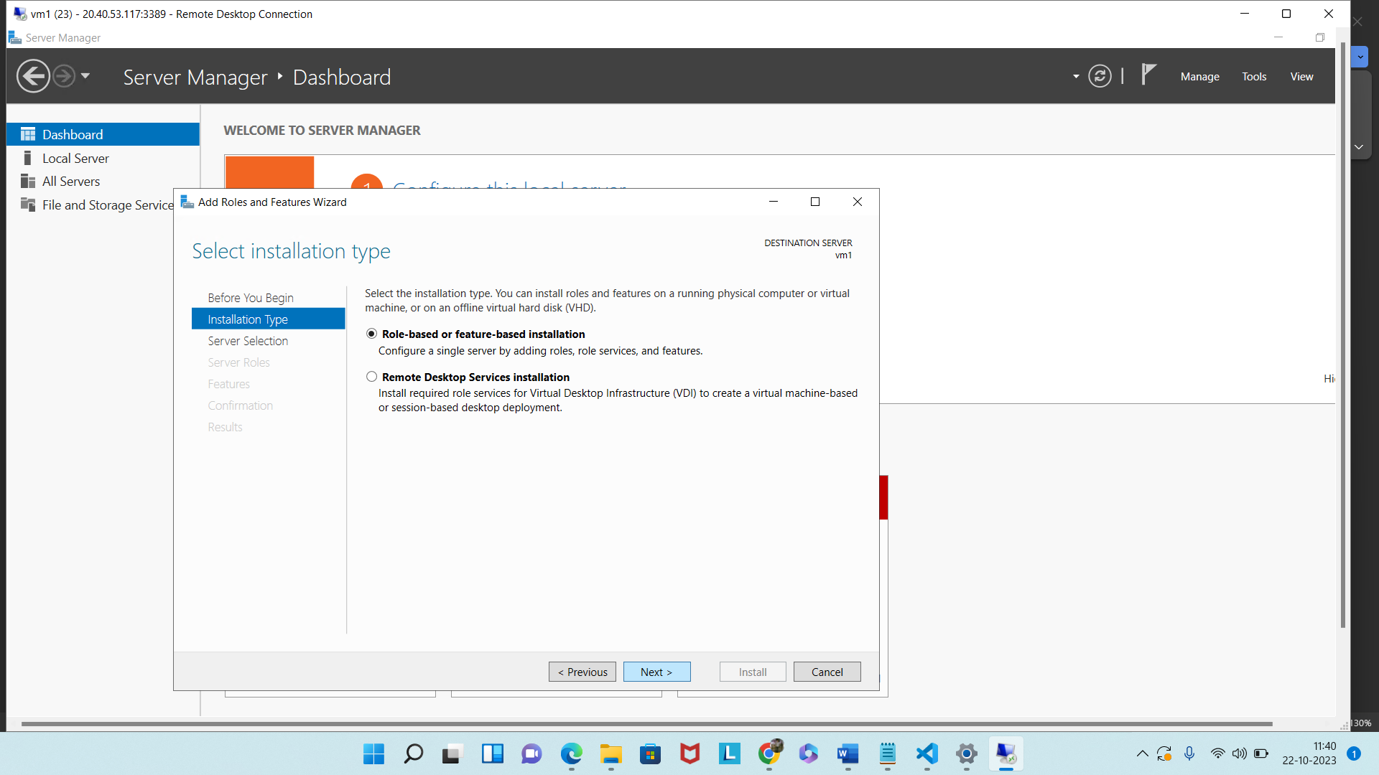

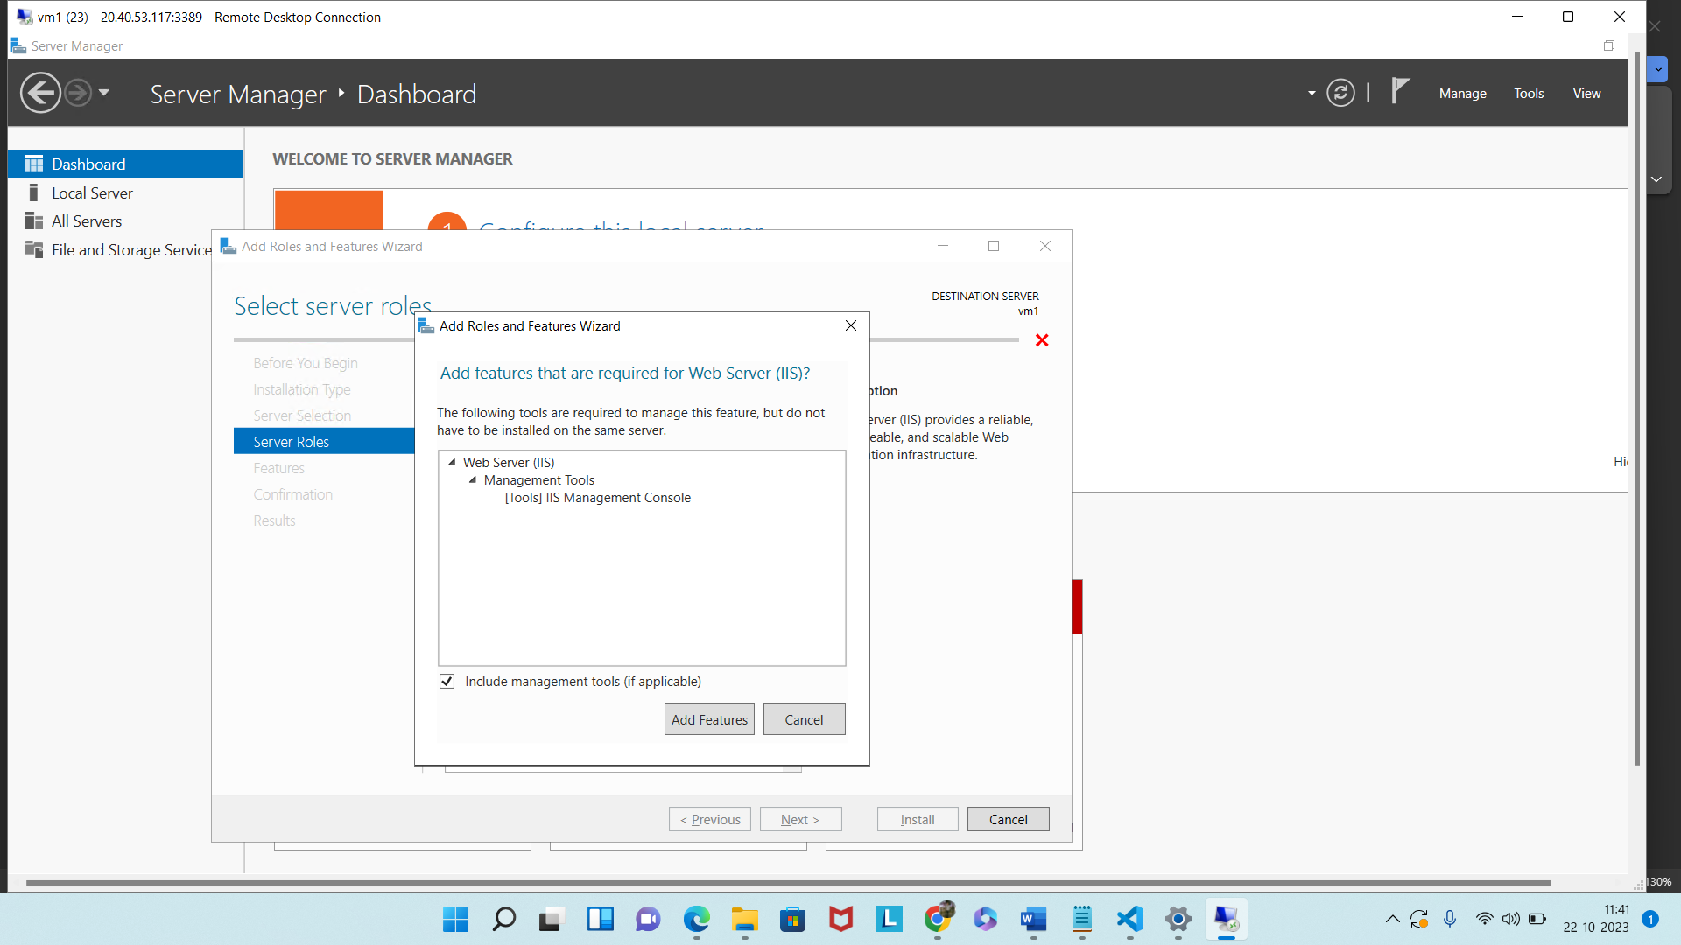

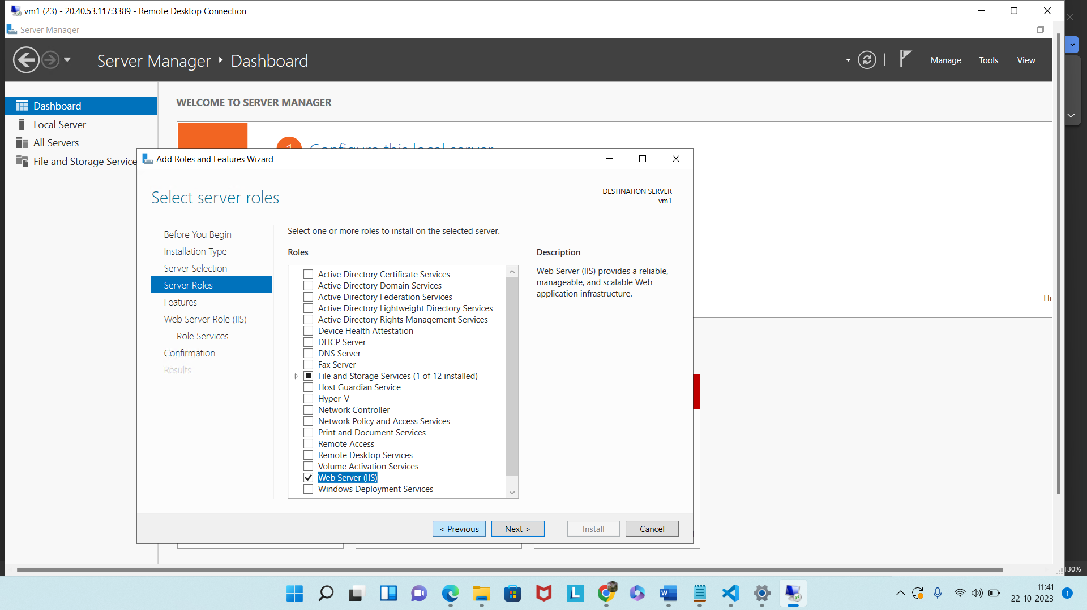

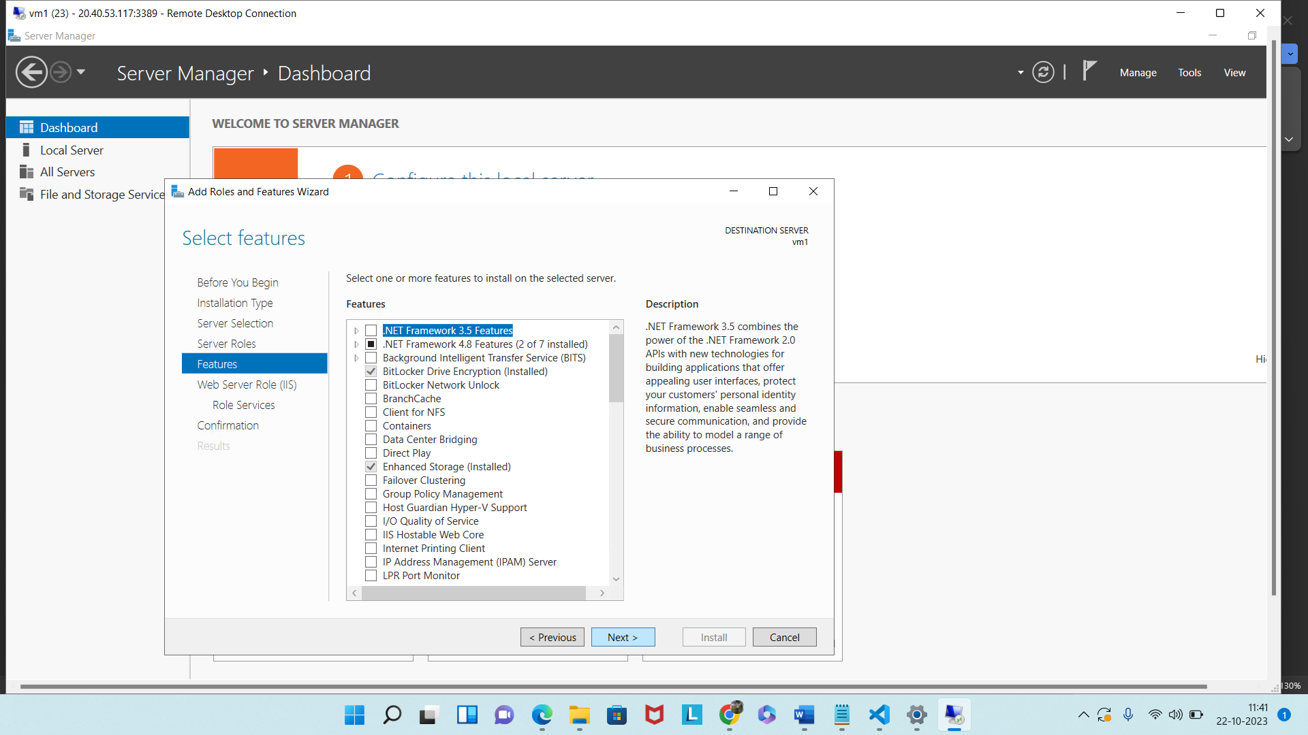

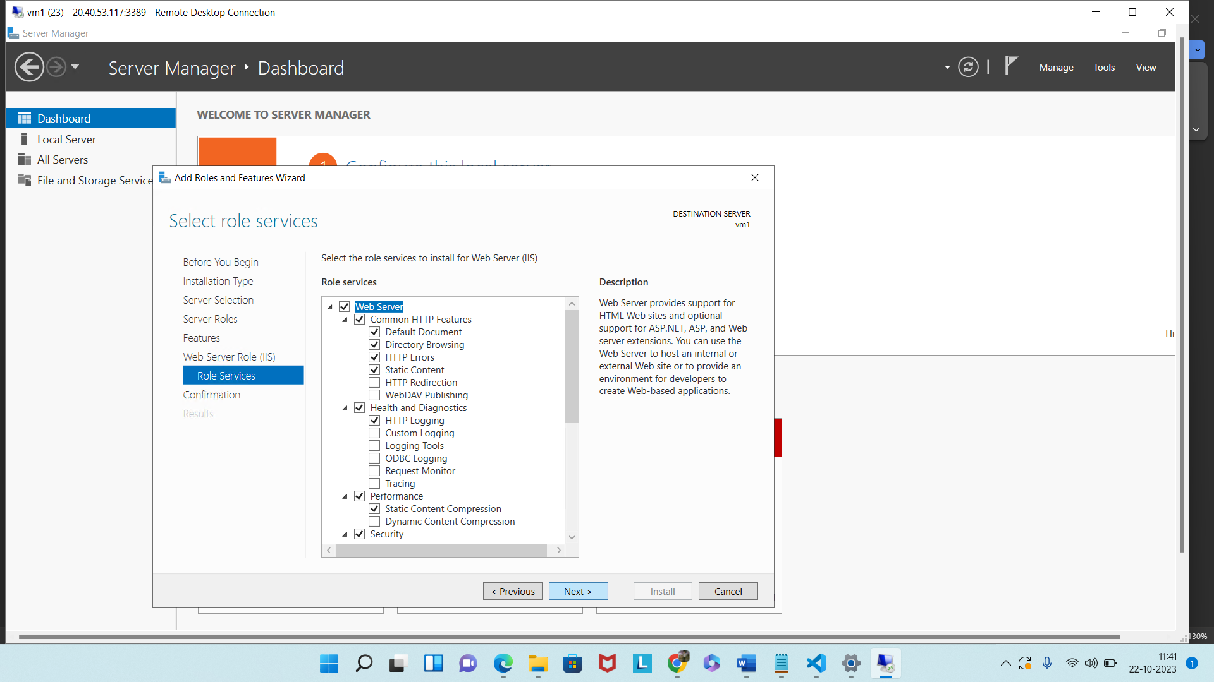

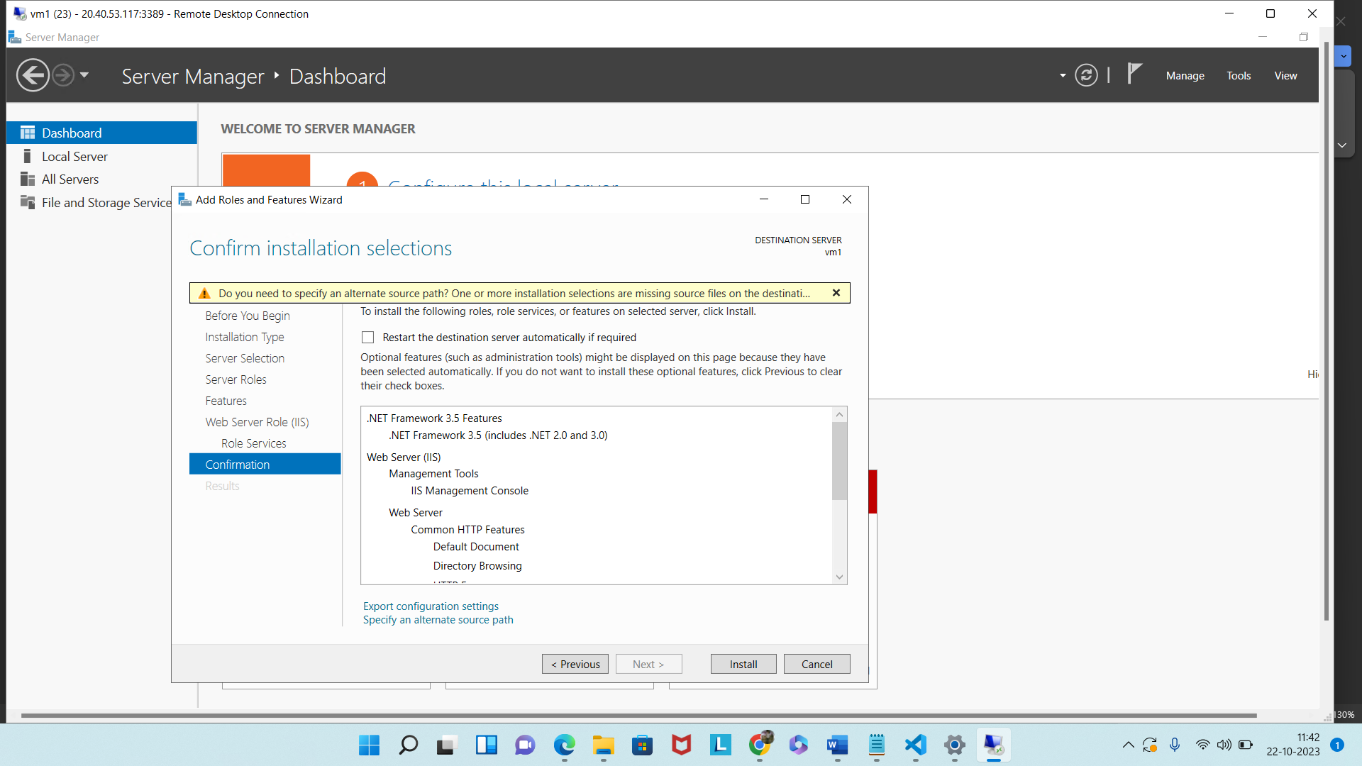

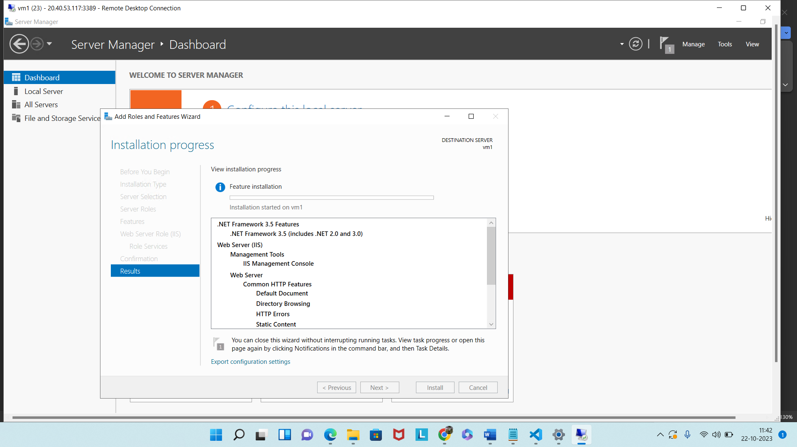

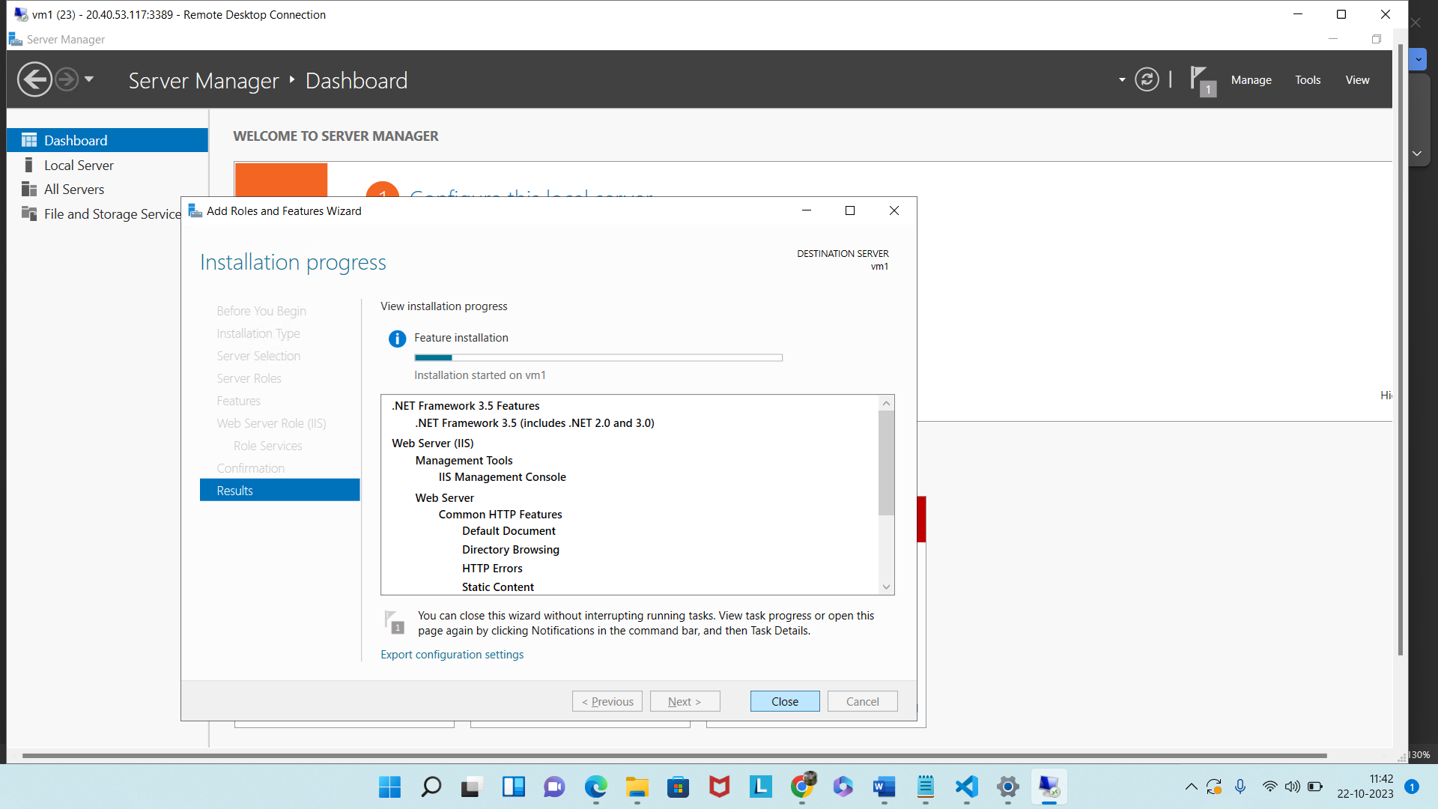

Now deploy a website.

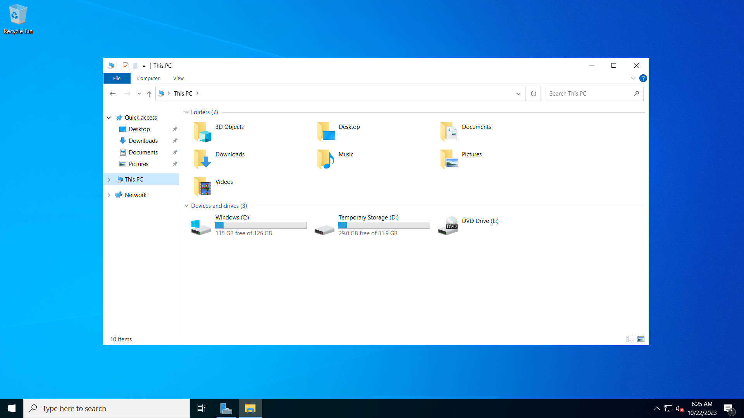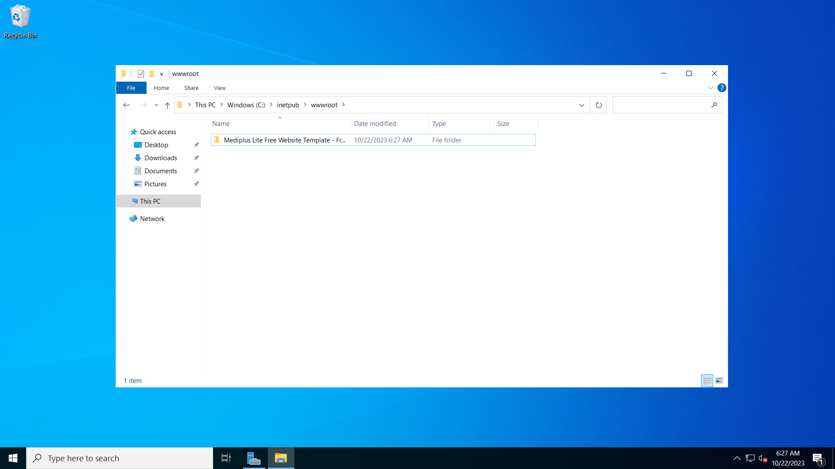

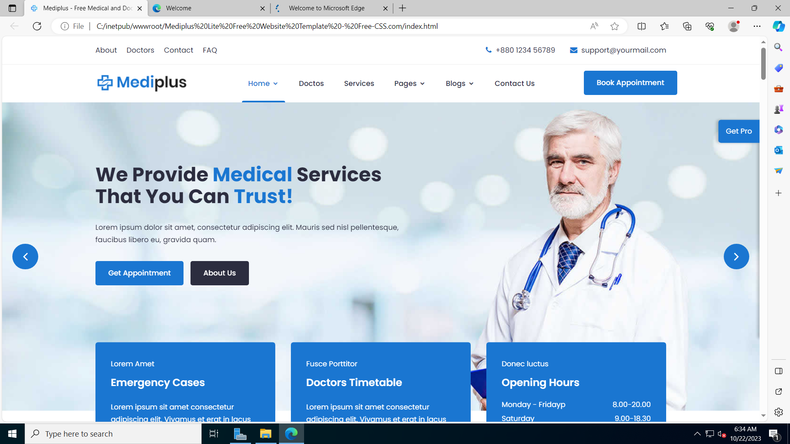

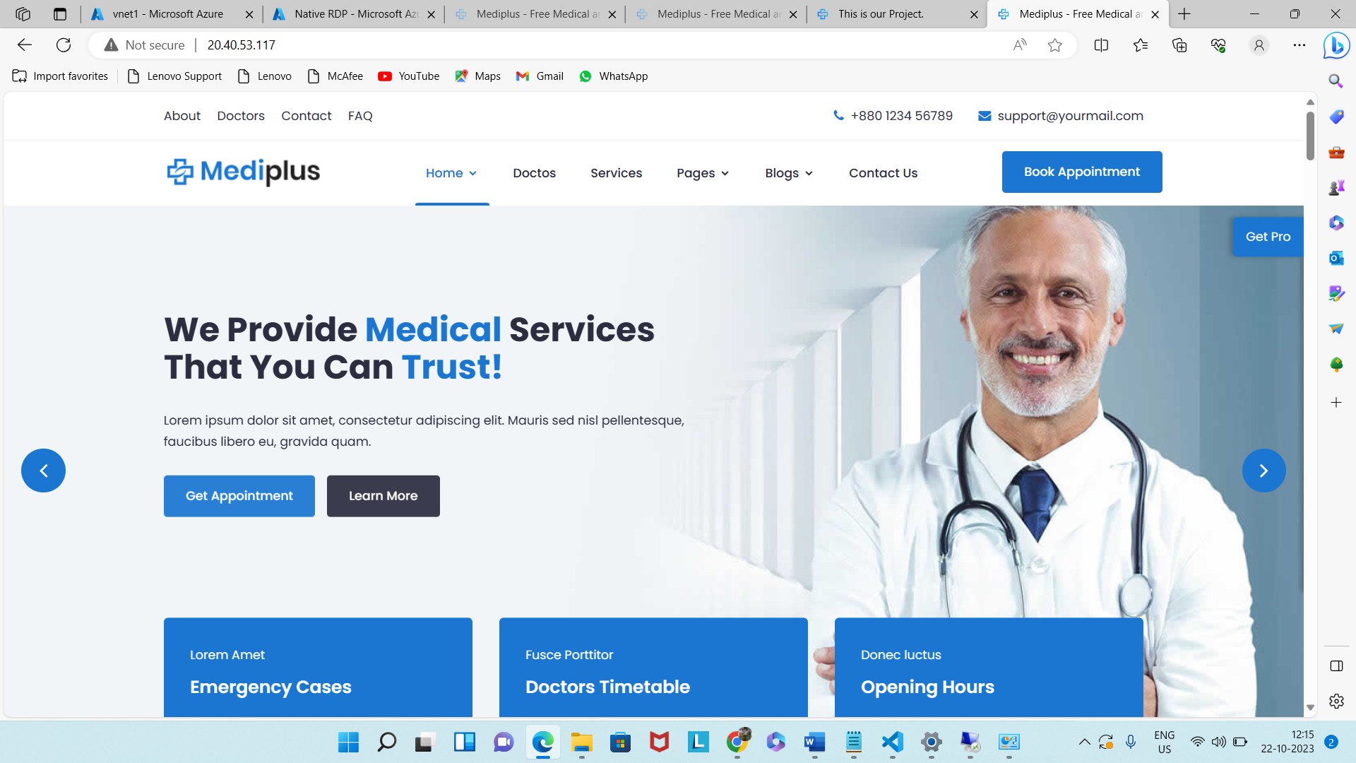

Create 2nd VM

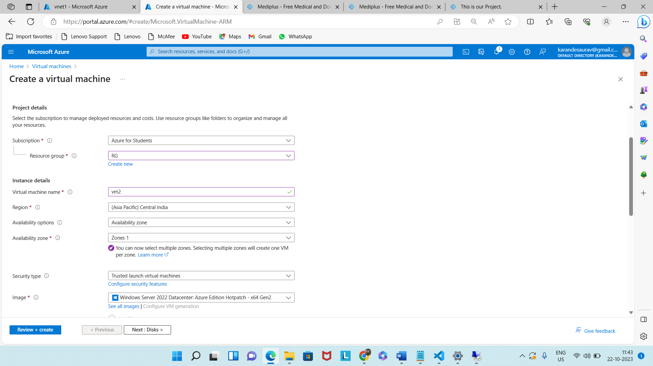

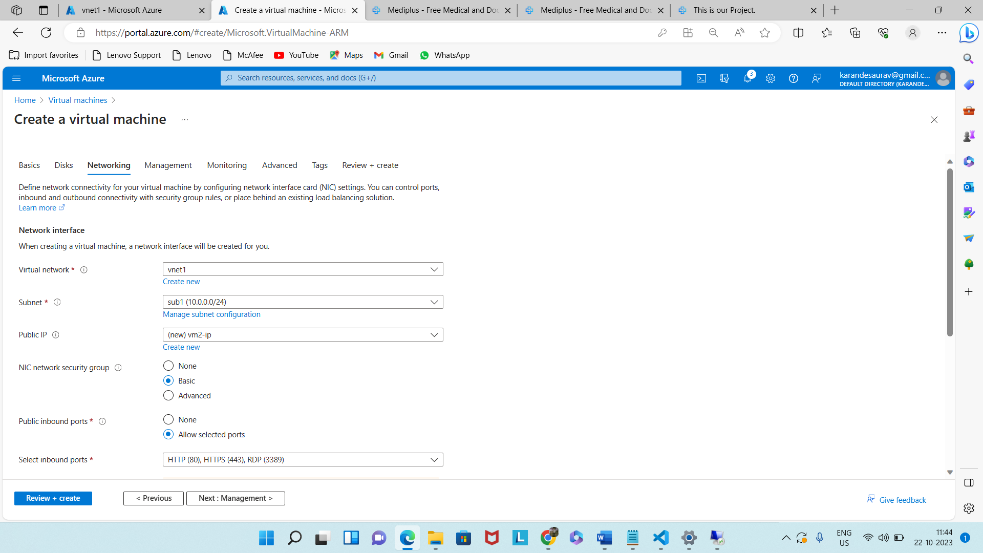

Connect 2nd VM.

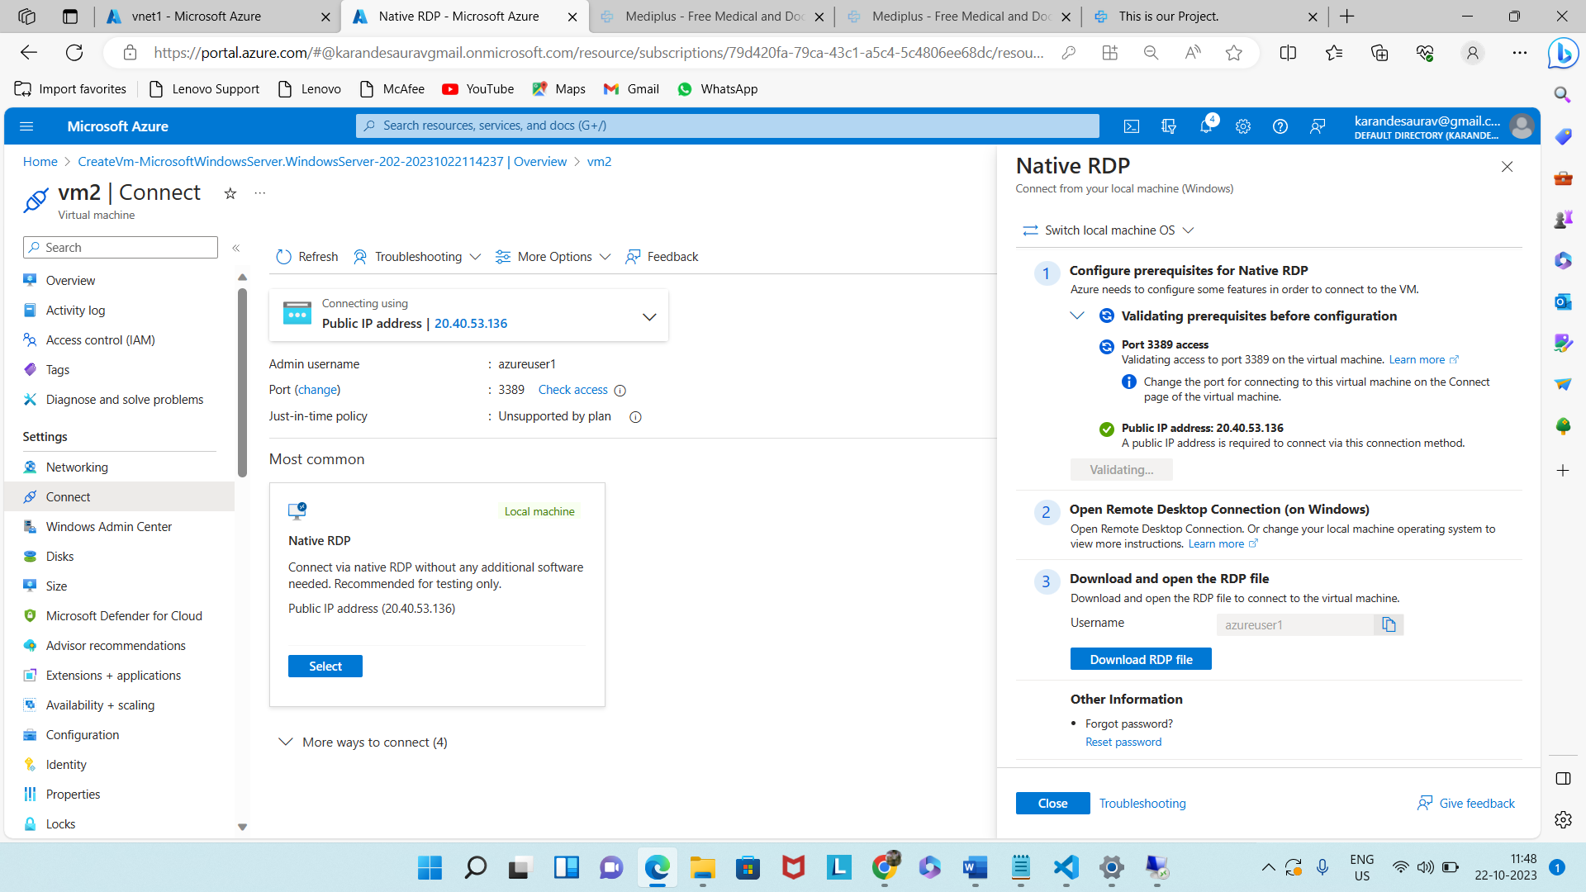

Install IIS in 2nd VM



















Now deploy a website in 1st VM.





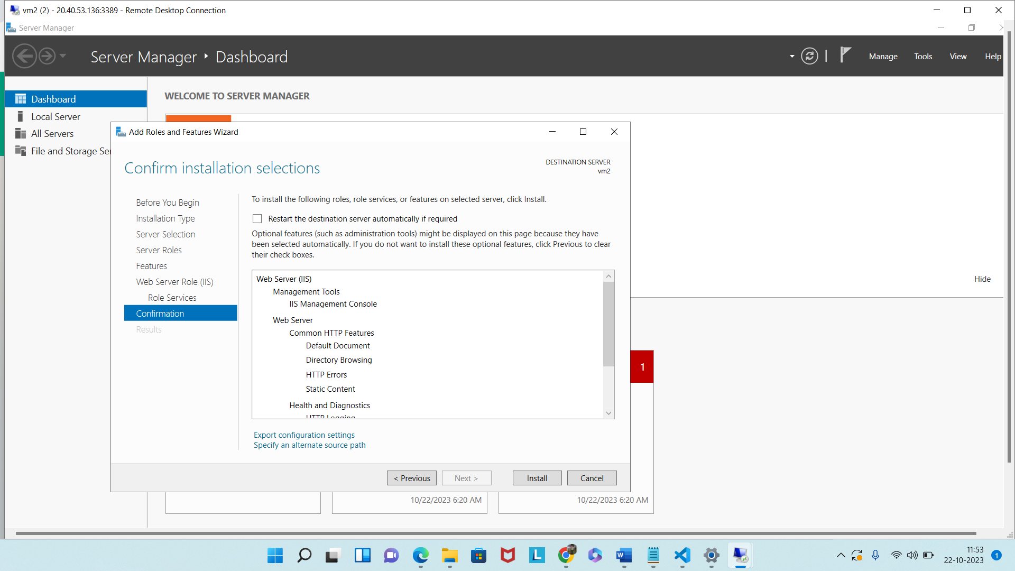

Deployment of website in 2nd VM



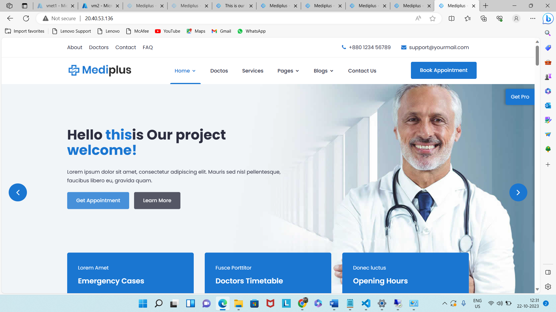

**Step 4:** Create application gateway.

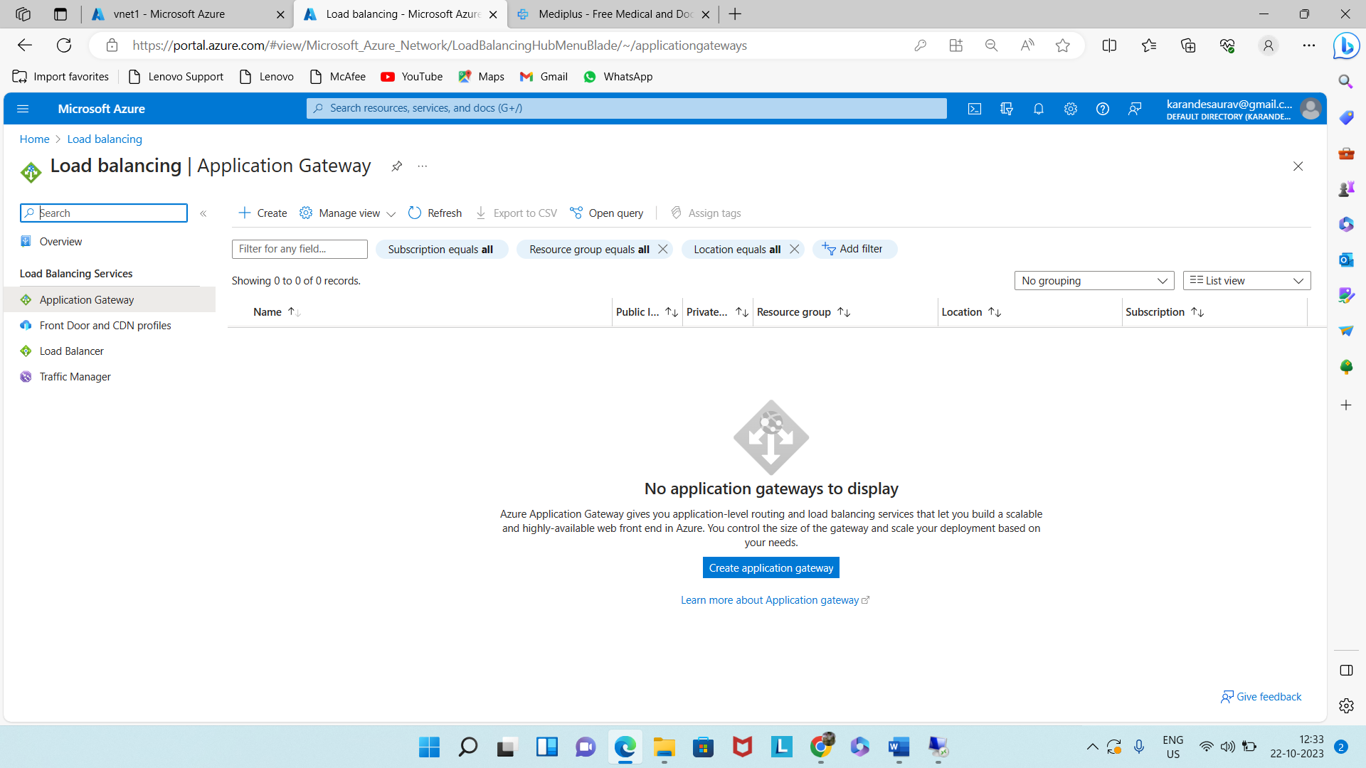

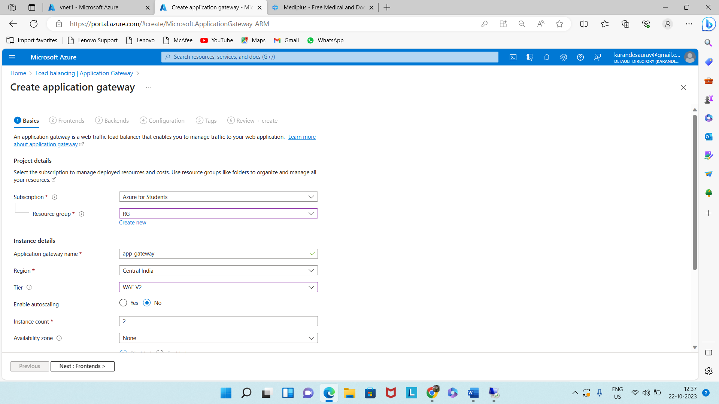

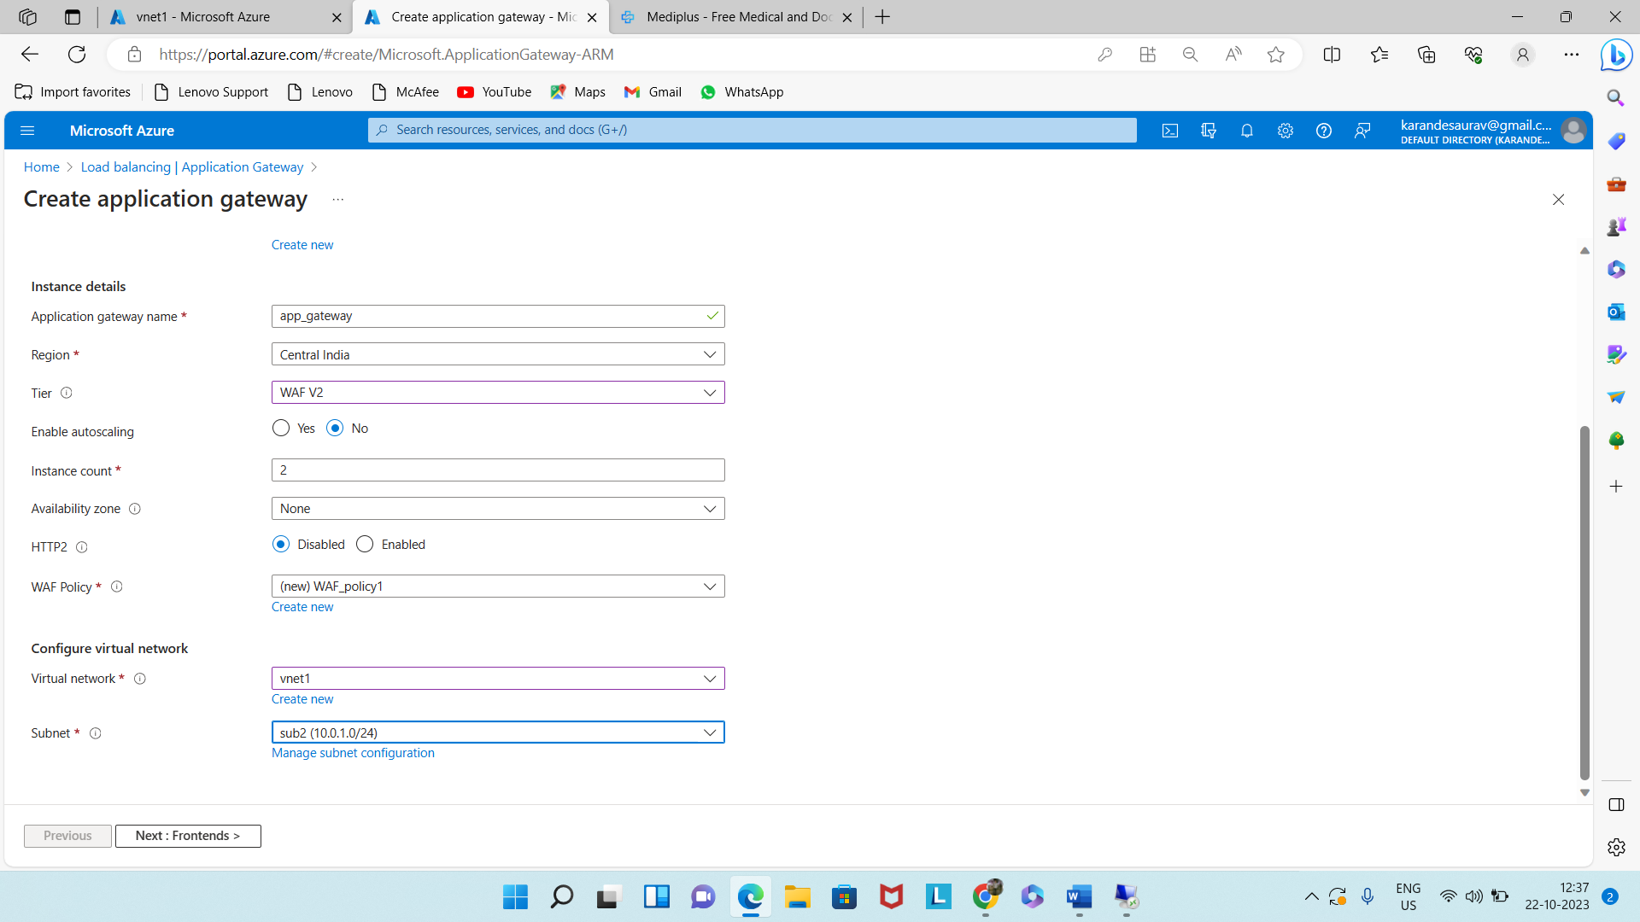

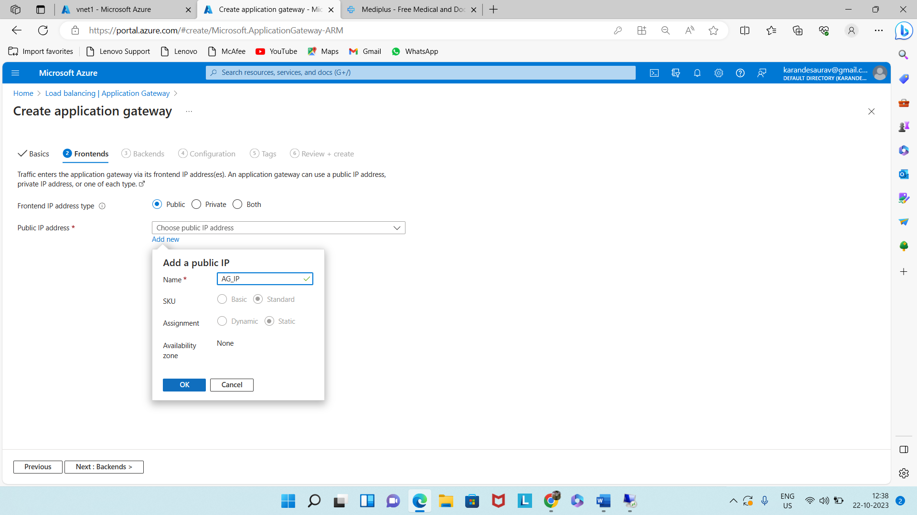

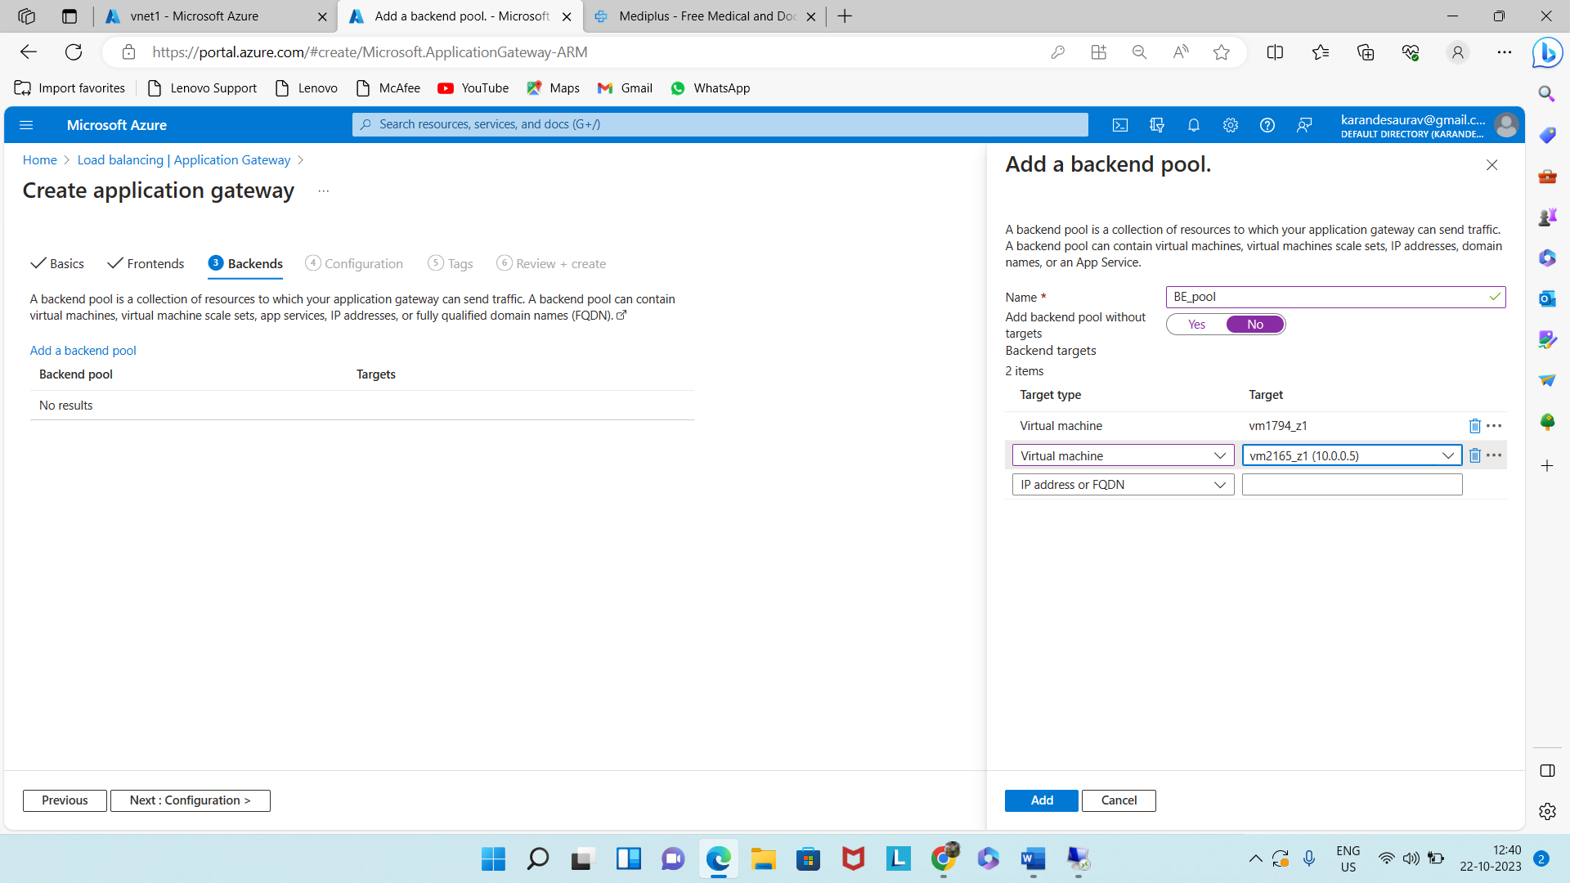

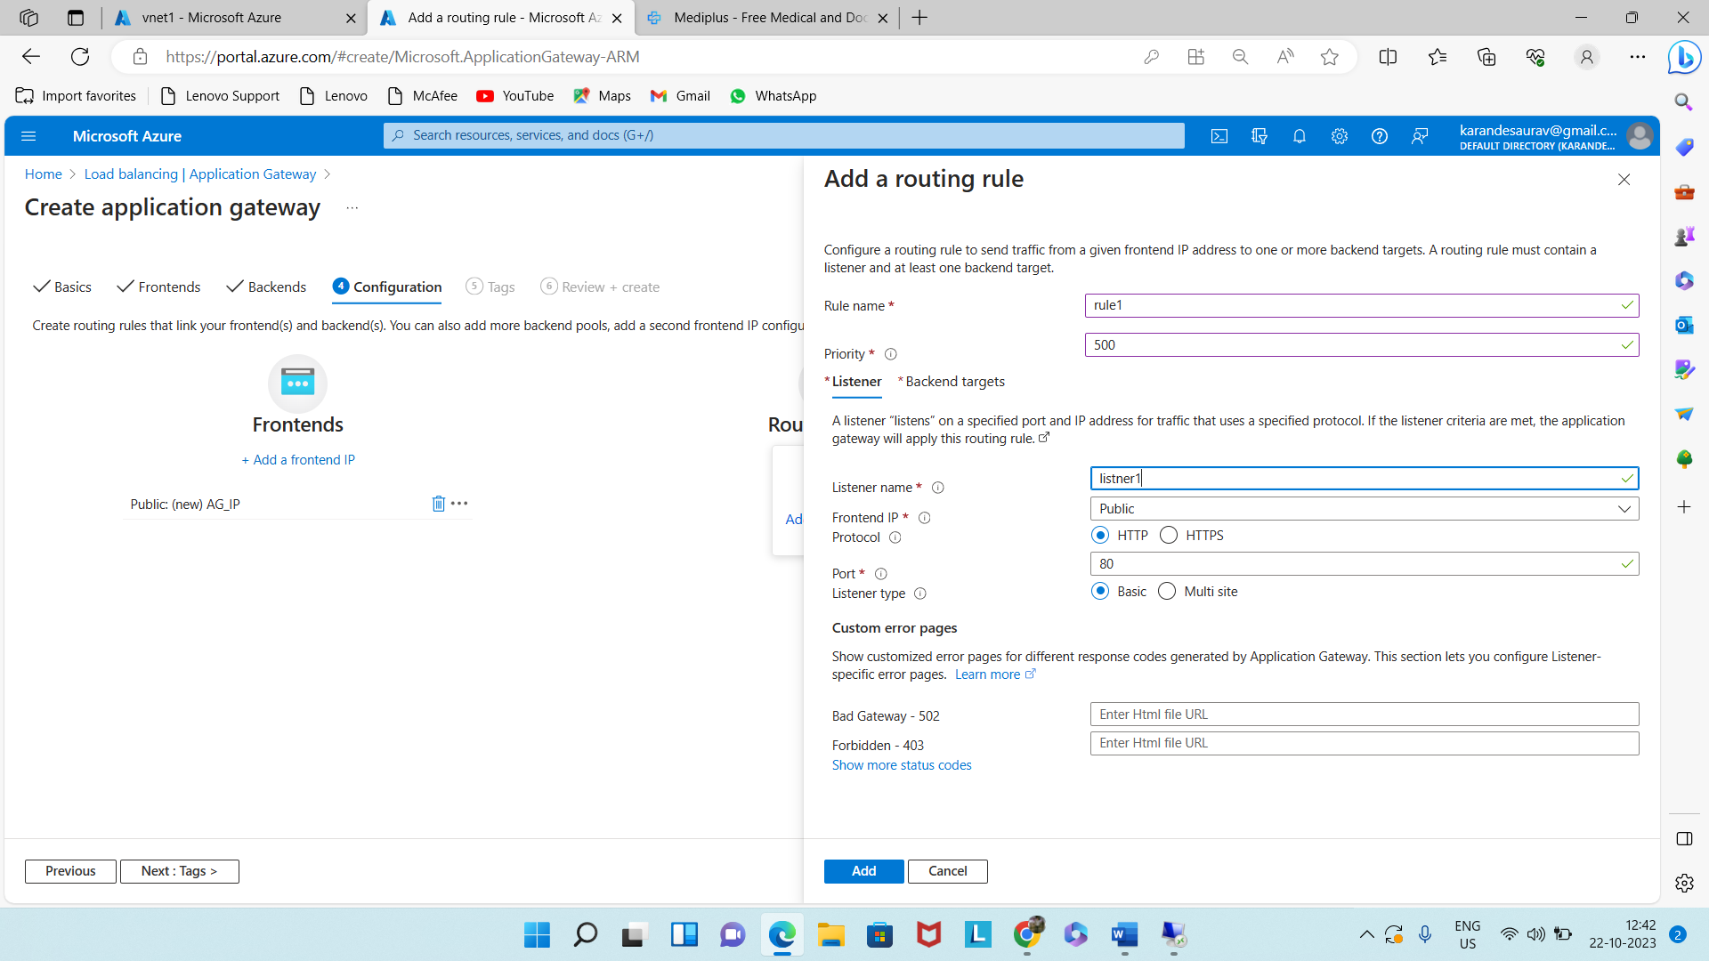

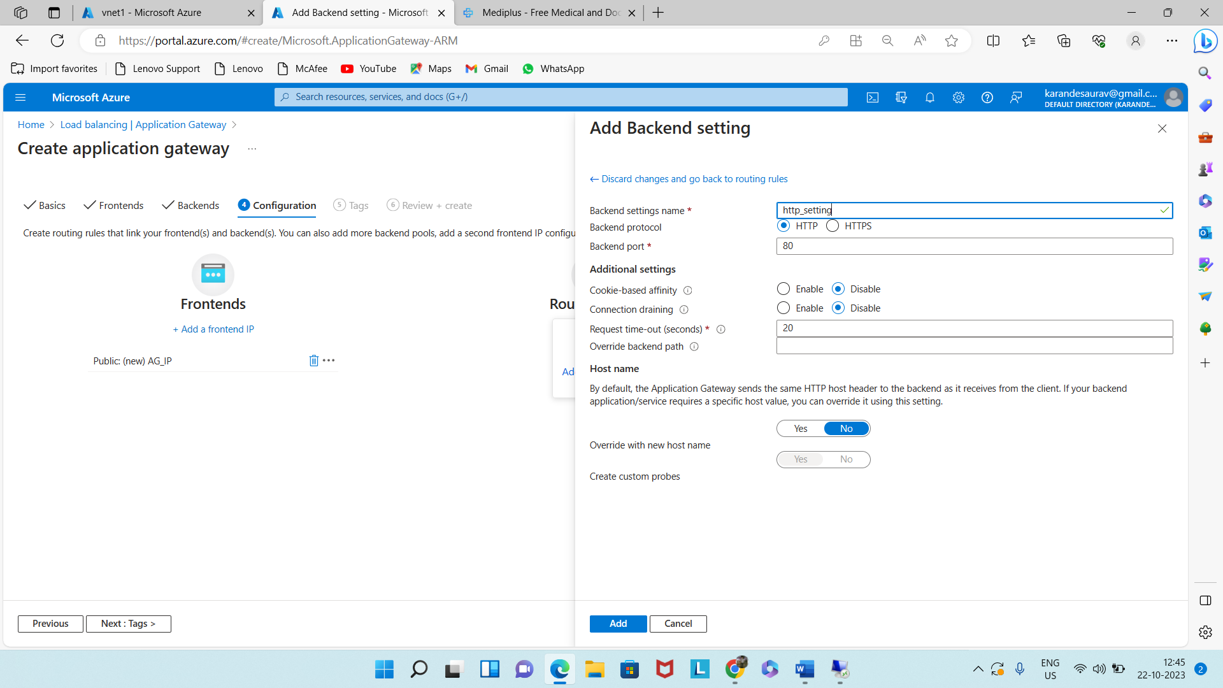

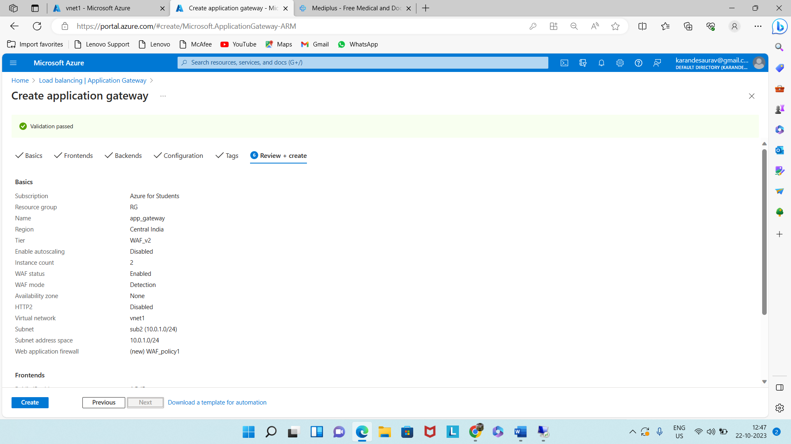

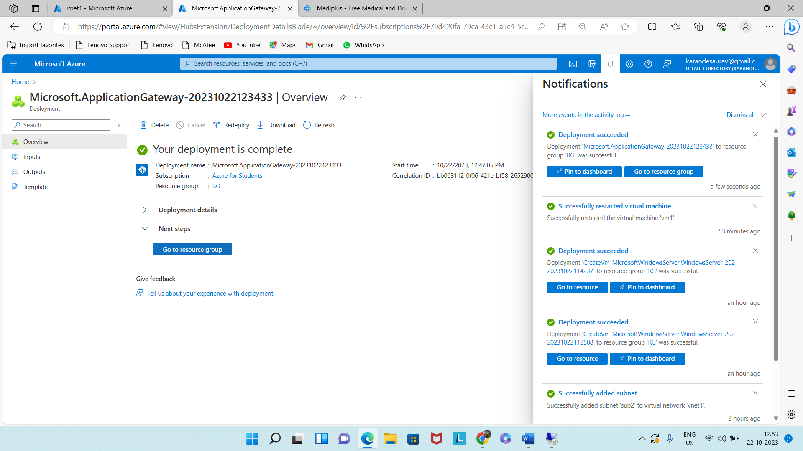

Now the load will be balance in both the VM.

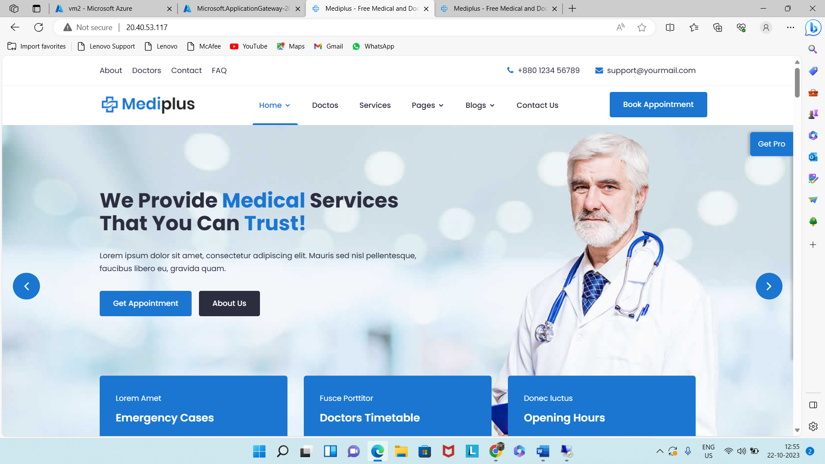

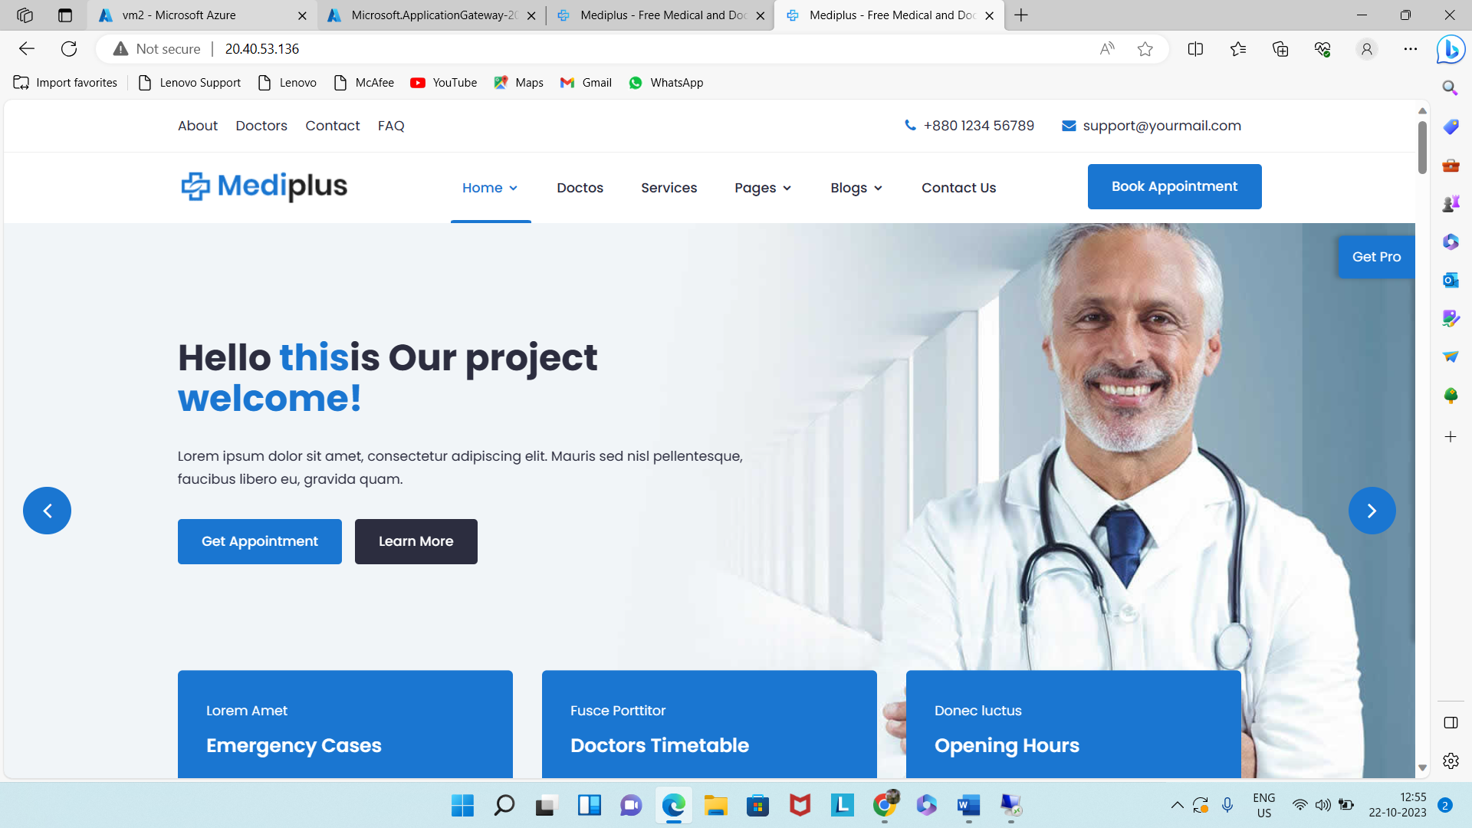

**Step 5:** Multi Factor Authentication (MFA).

Active Directory >> New User > Create

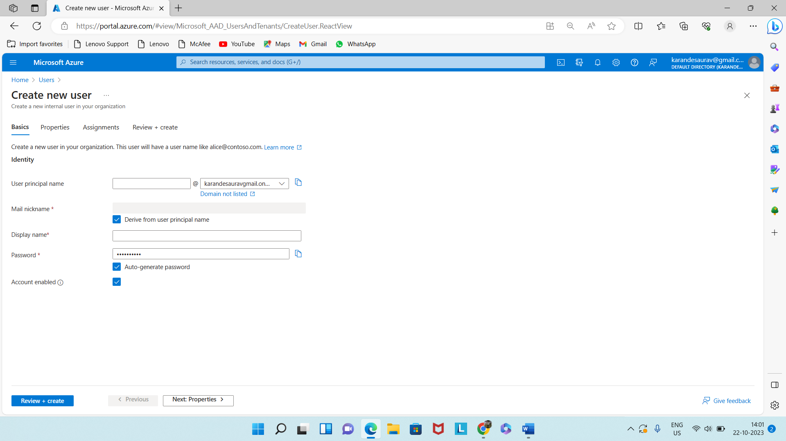

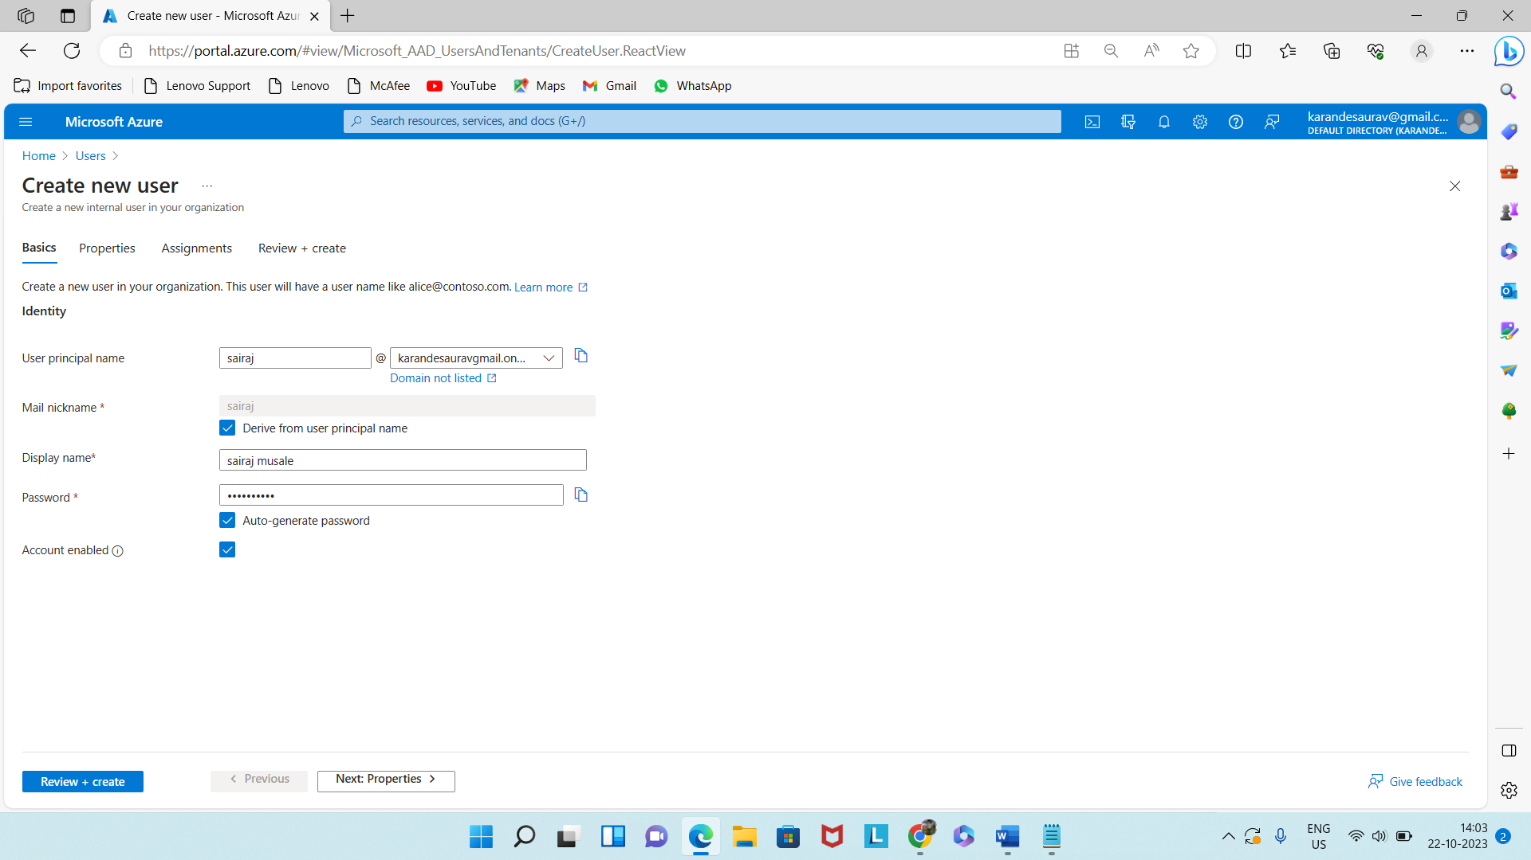

Assign a role ( Global Administrator)

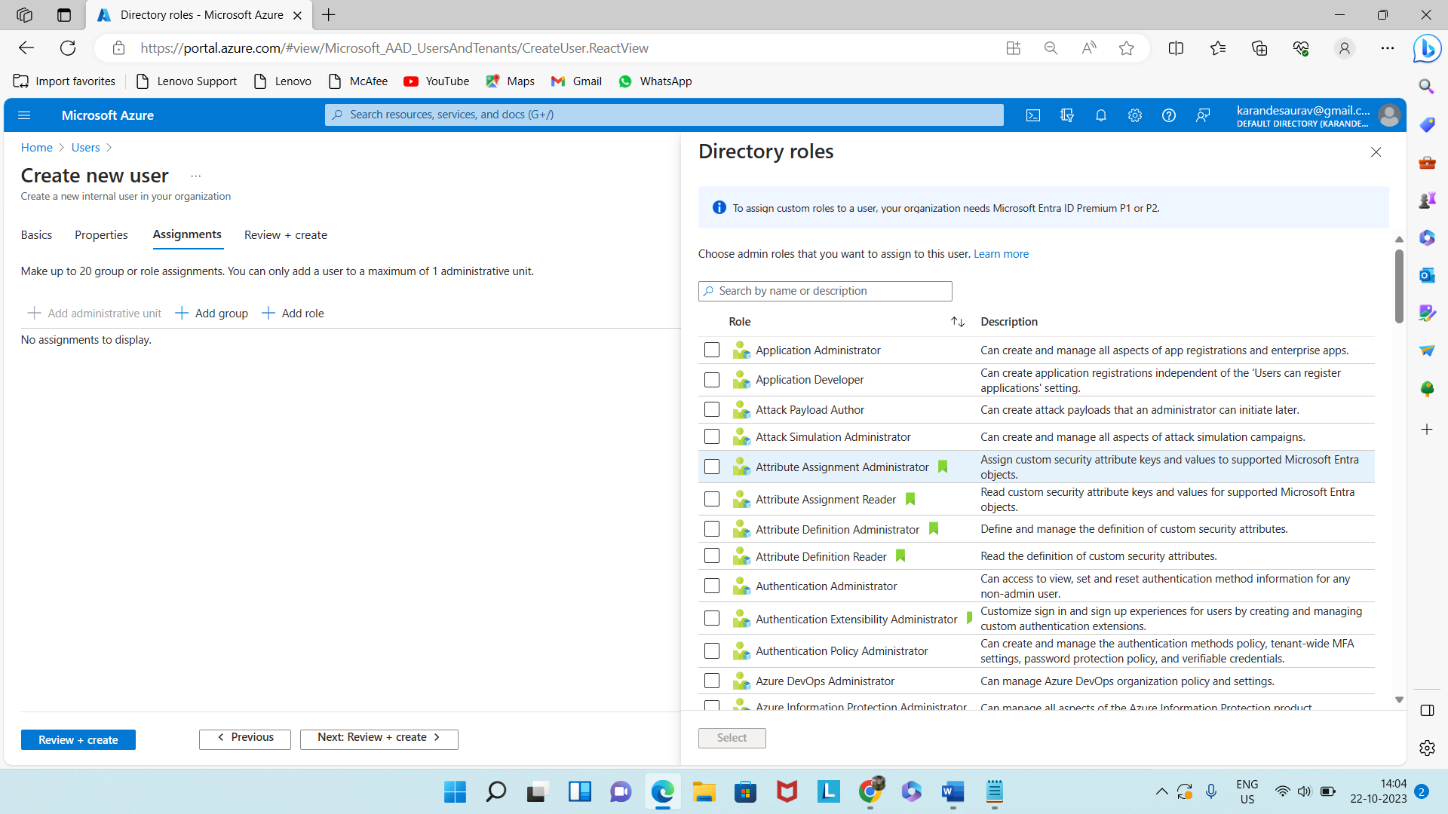

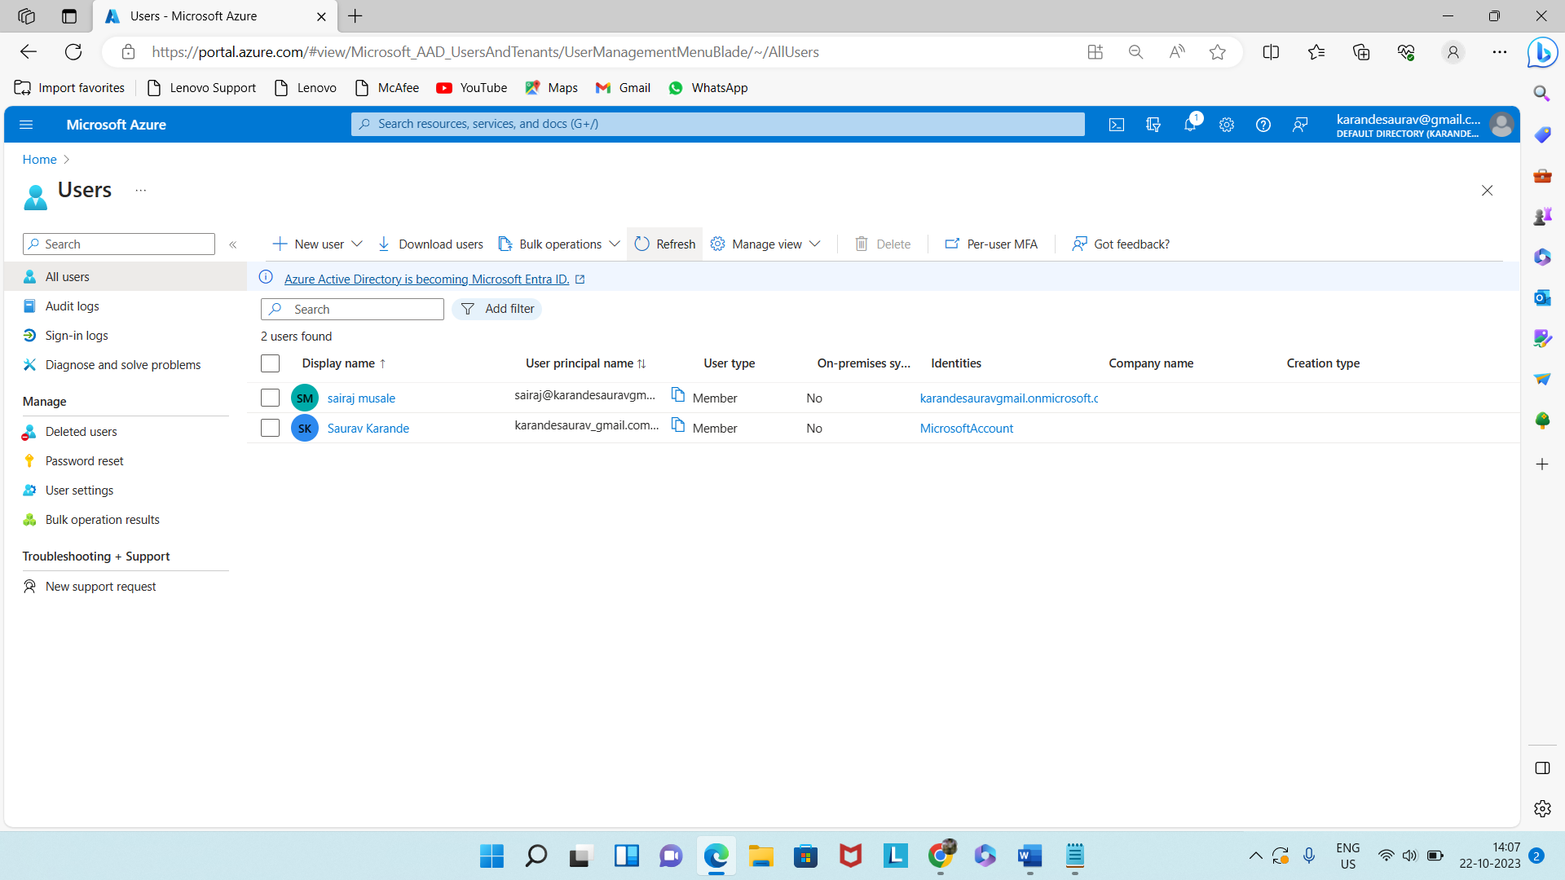

Now go to per-user MFA

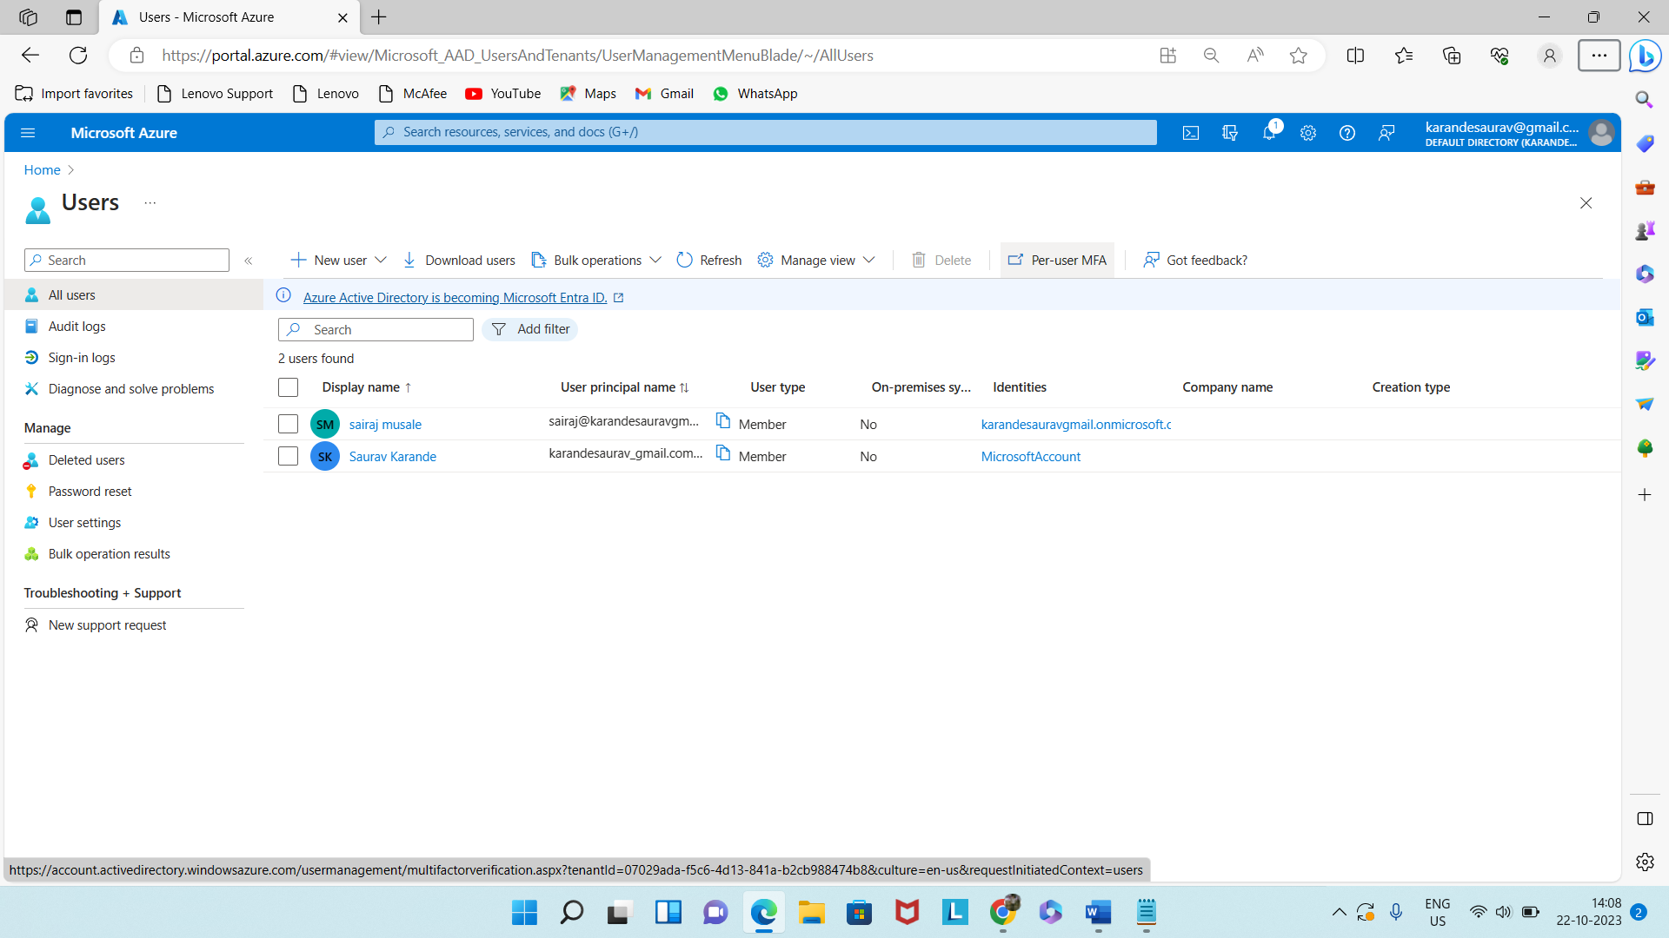

Now Enable the user.

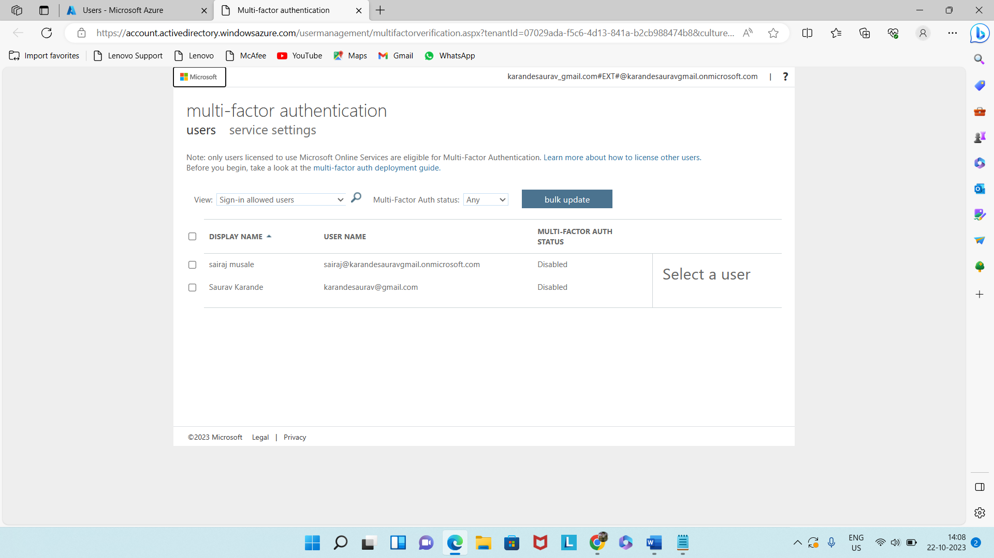

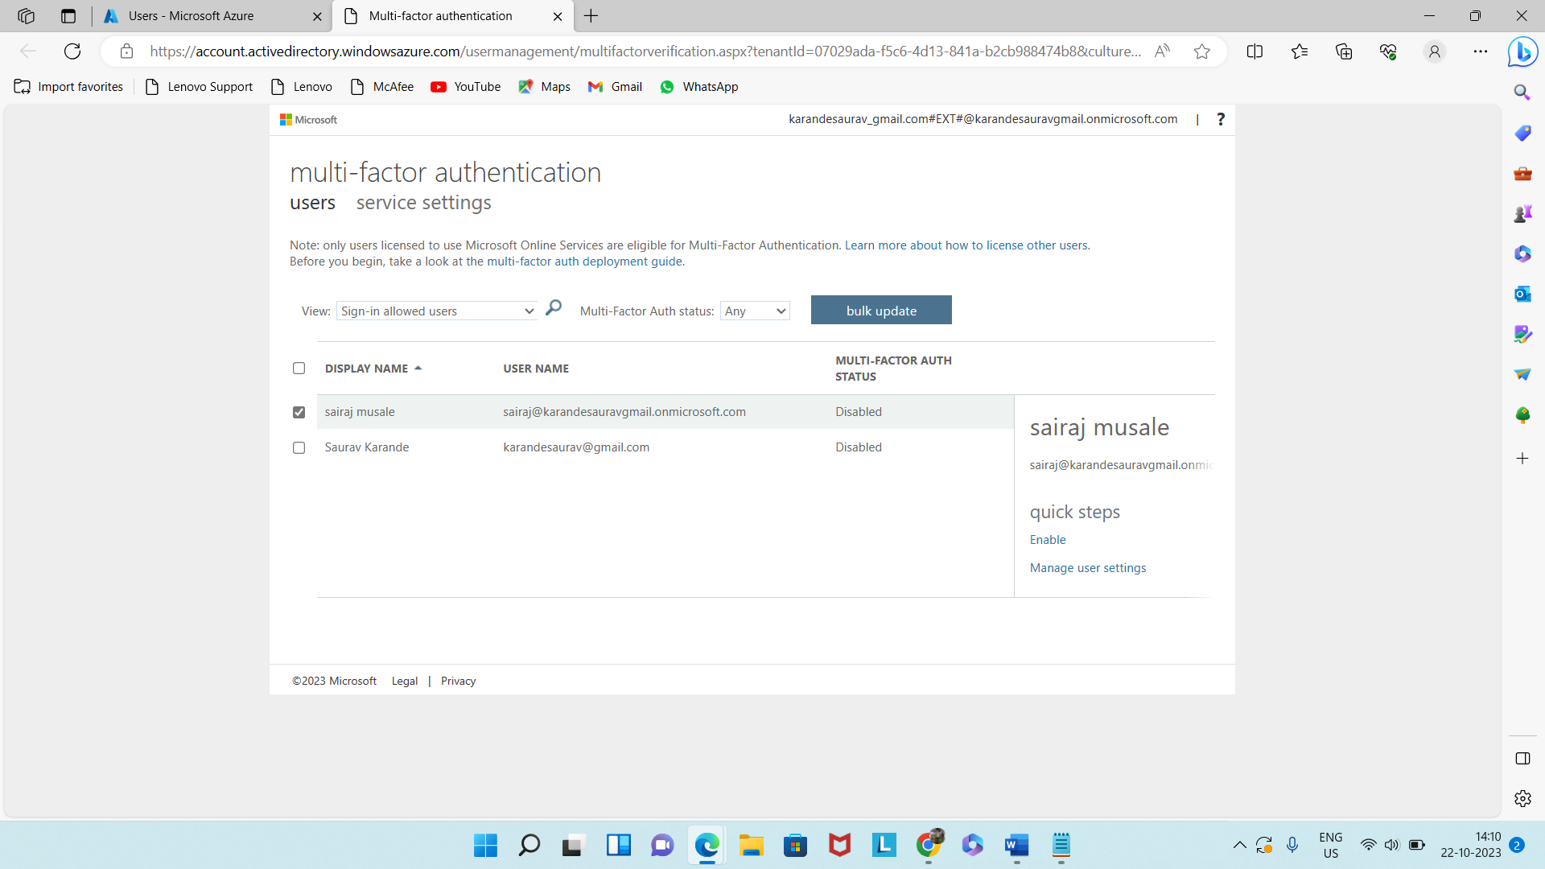

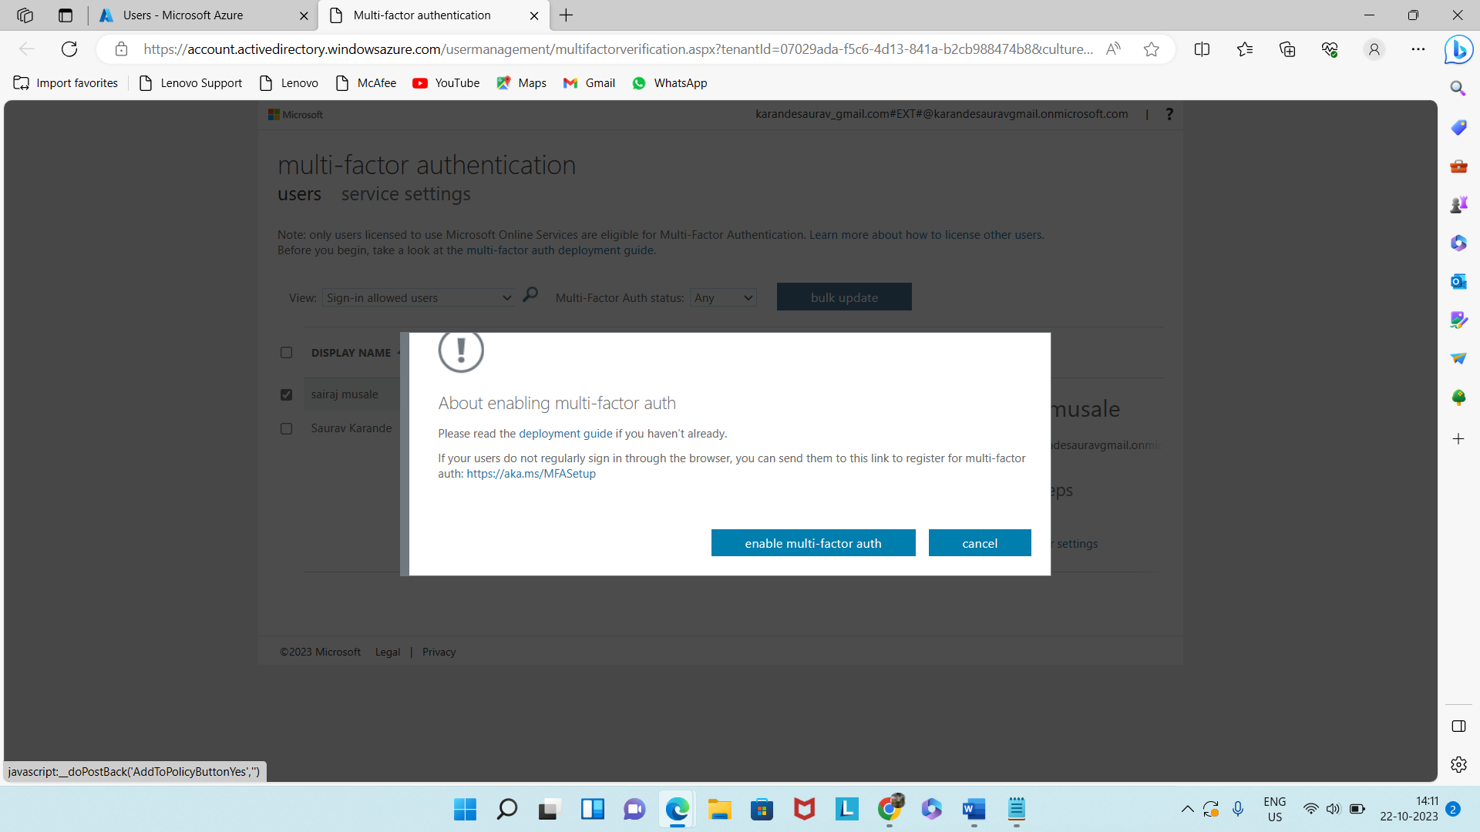

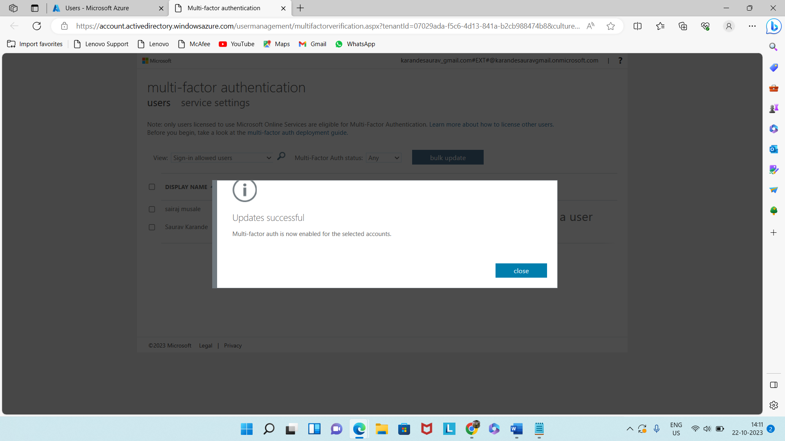

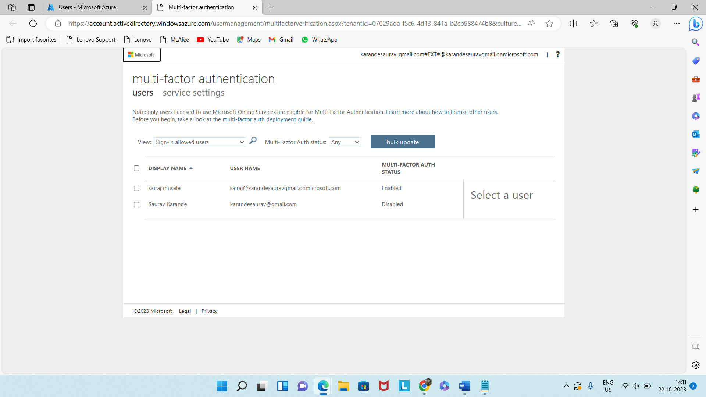

Go to Incongito window to serach for azure login.

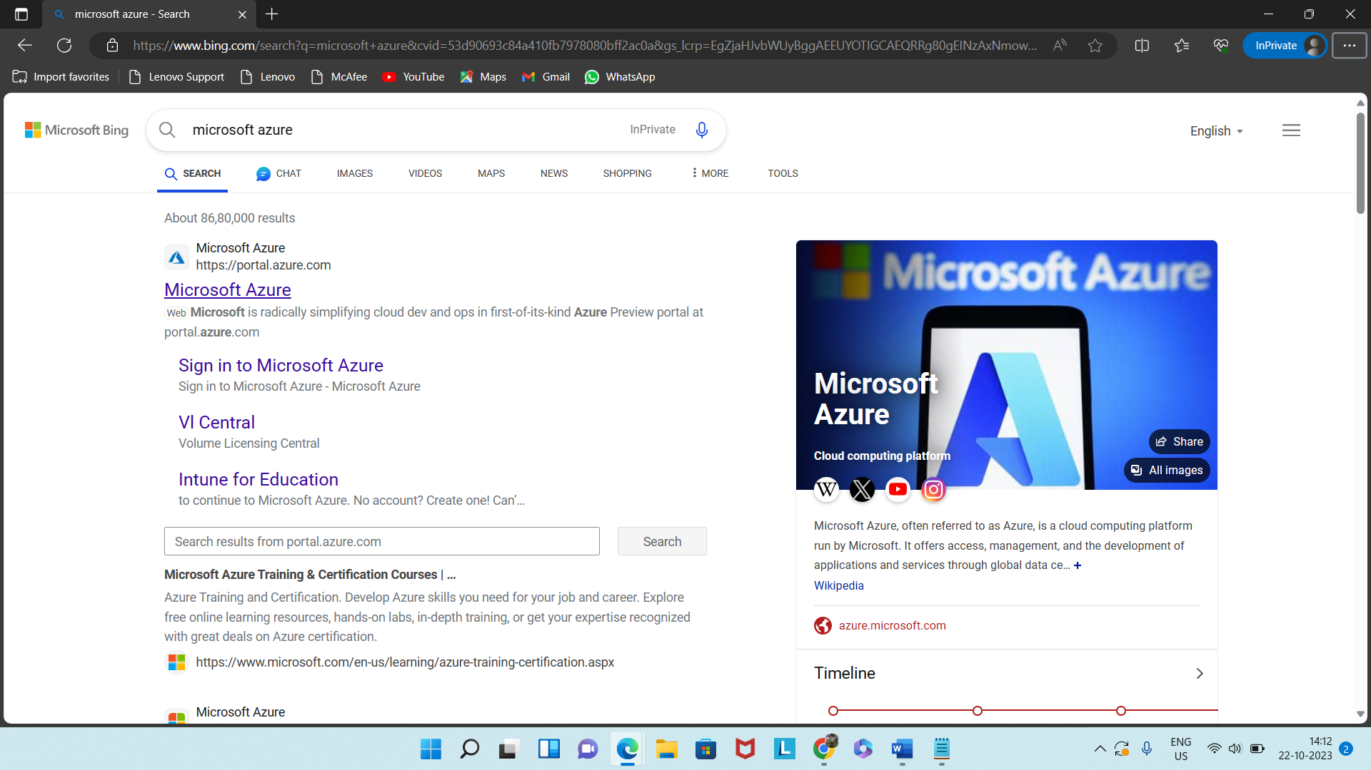

Sign up by user id

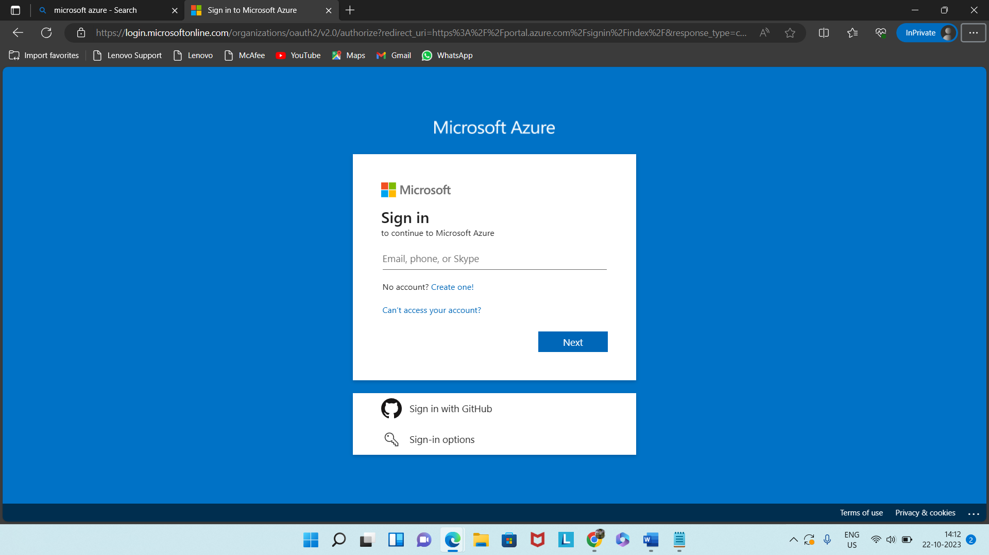

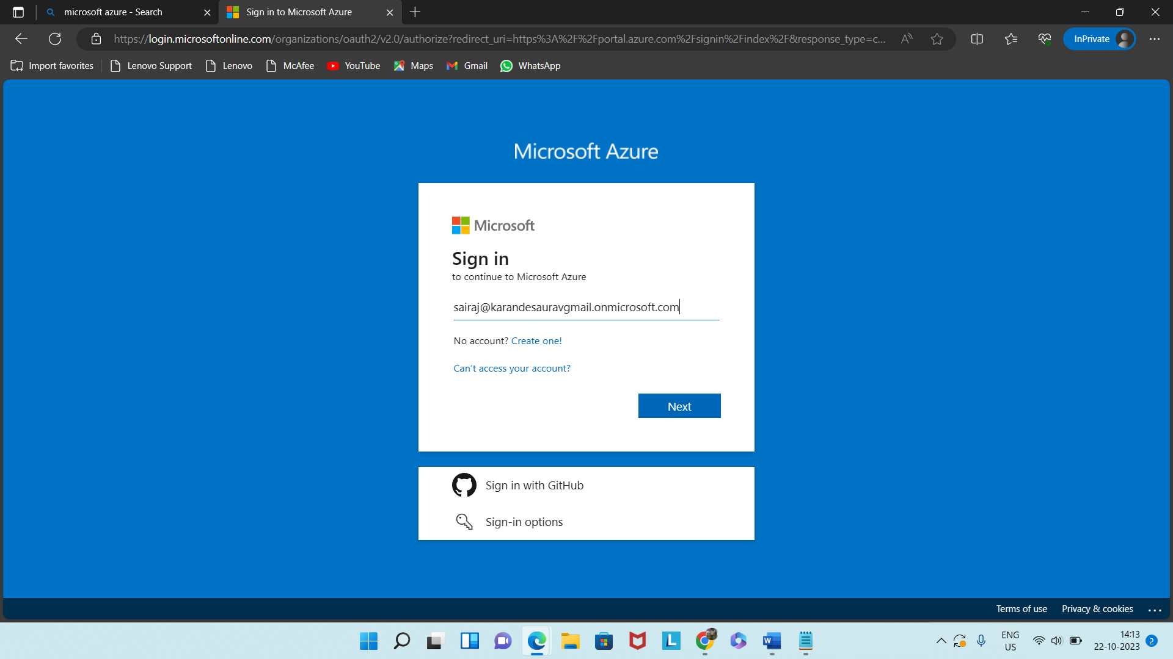

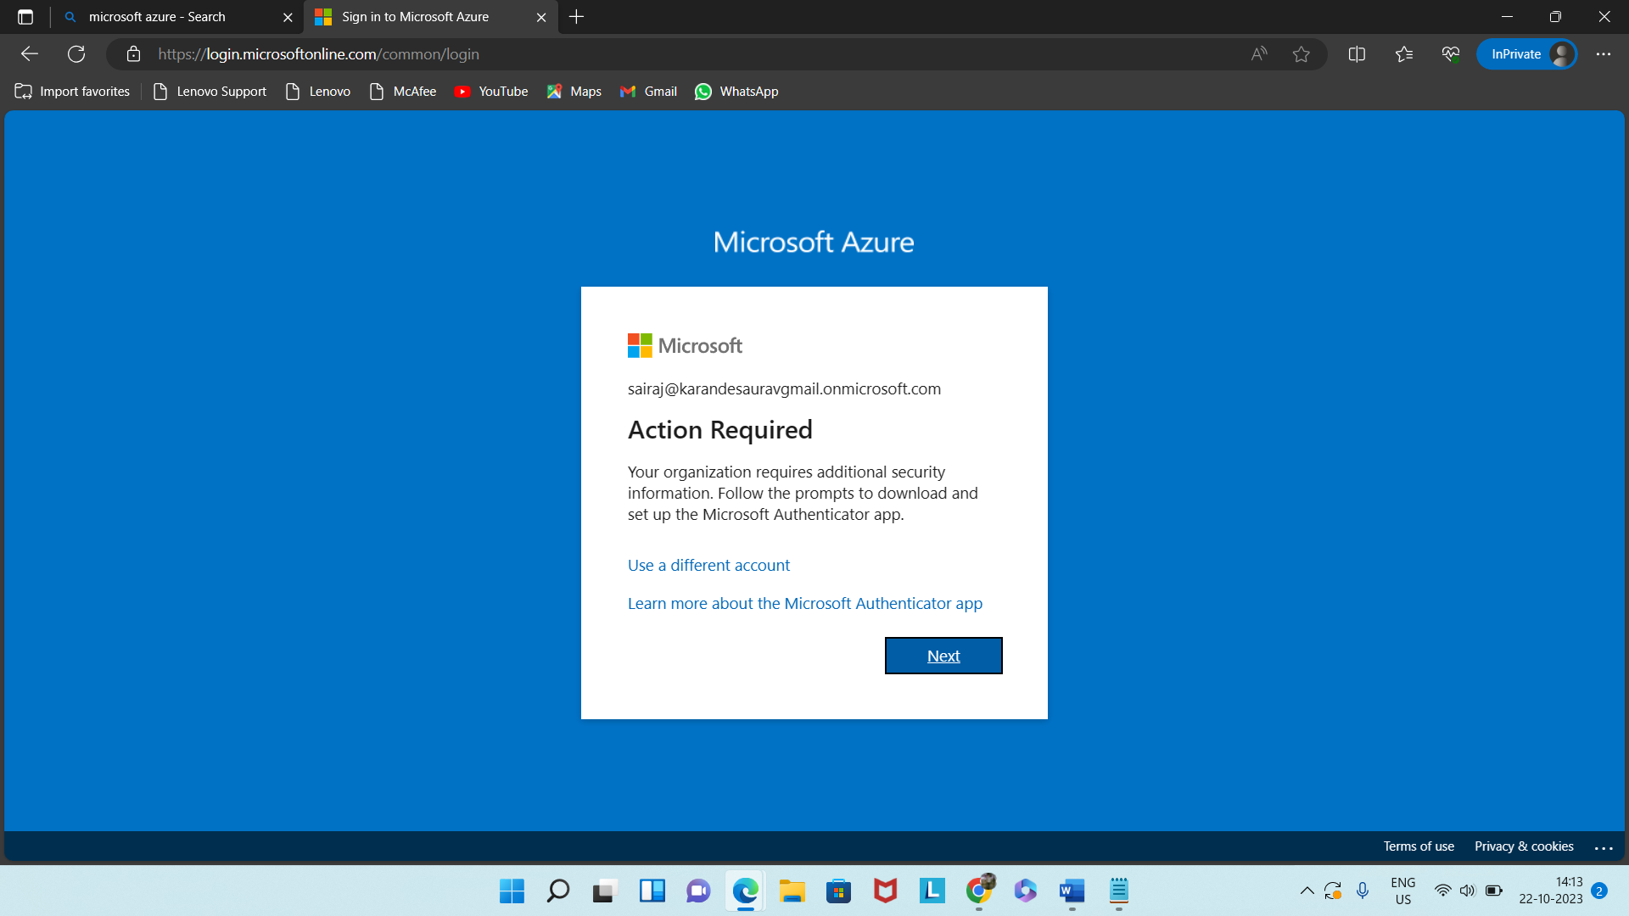

Now install Microsoft Authenticator app in mobile.

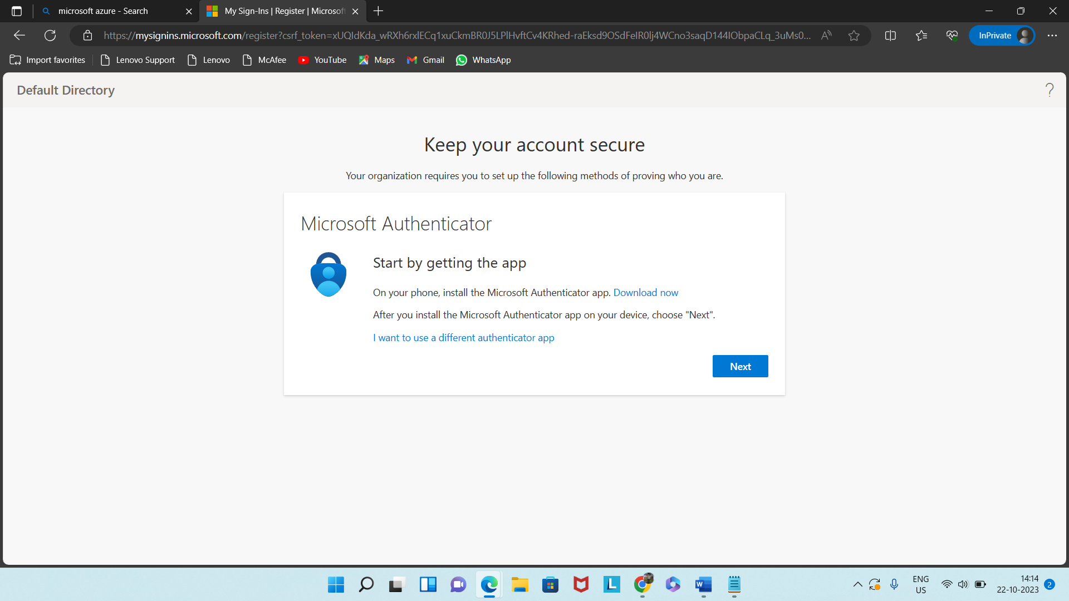

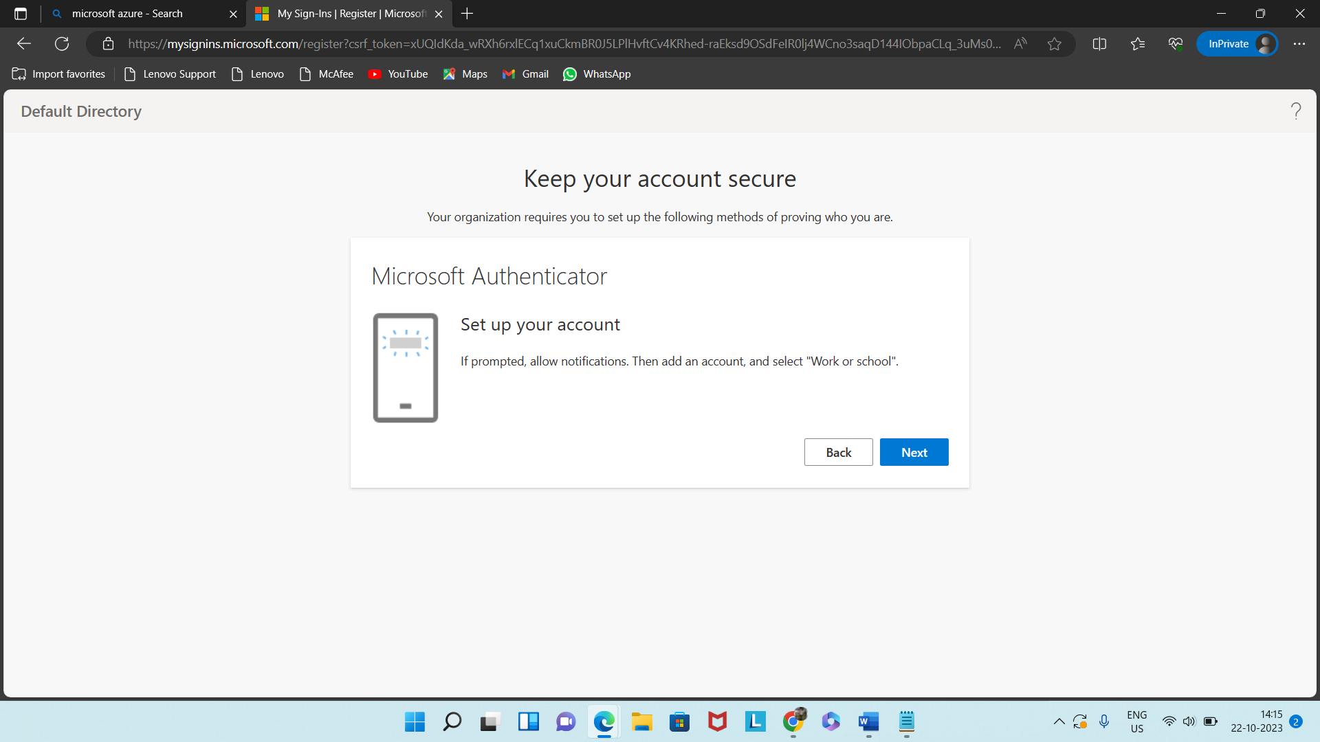

Scan the code.

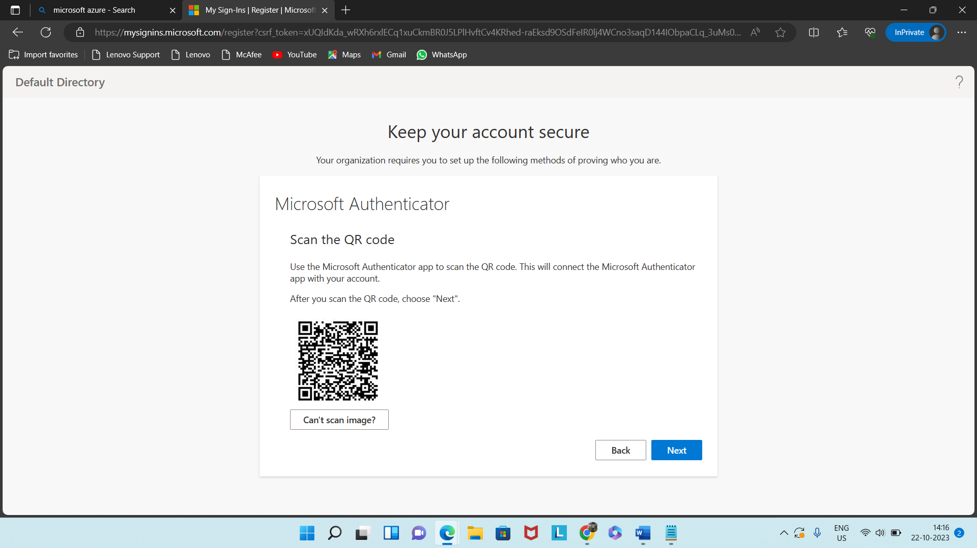

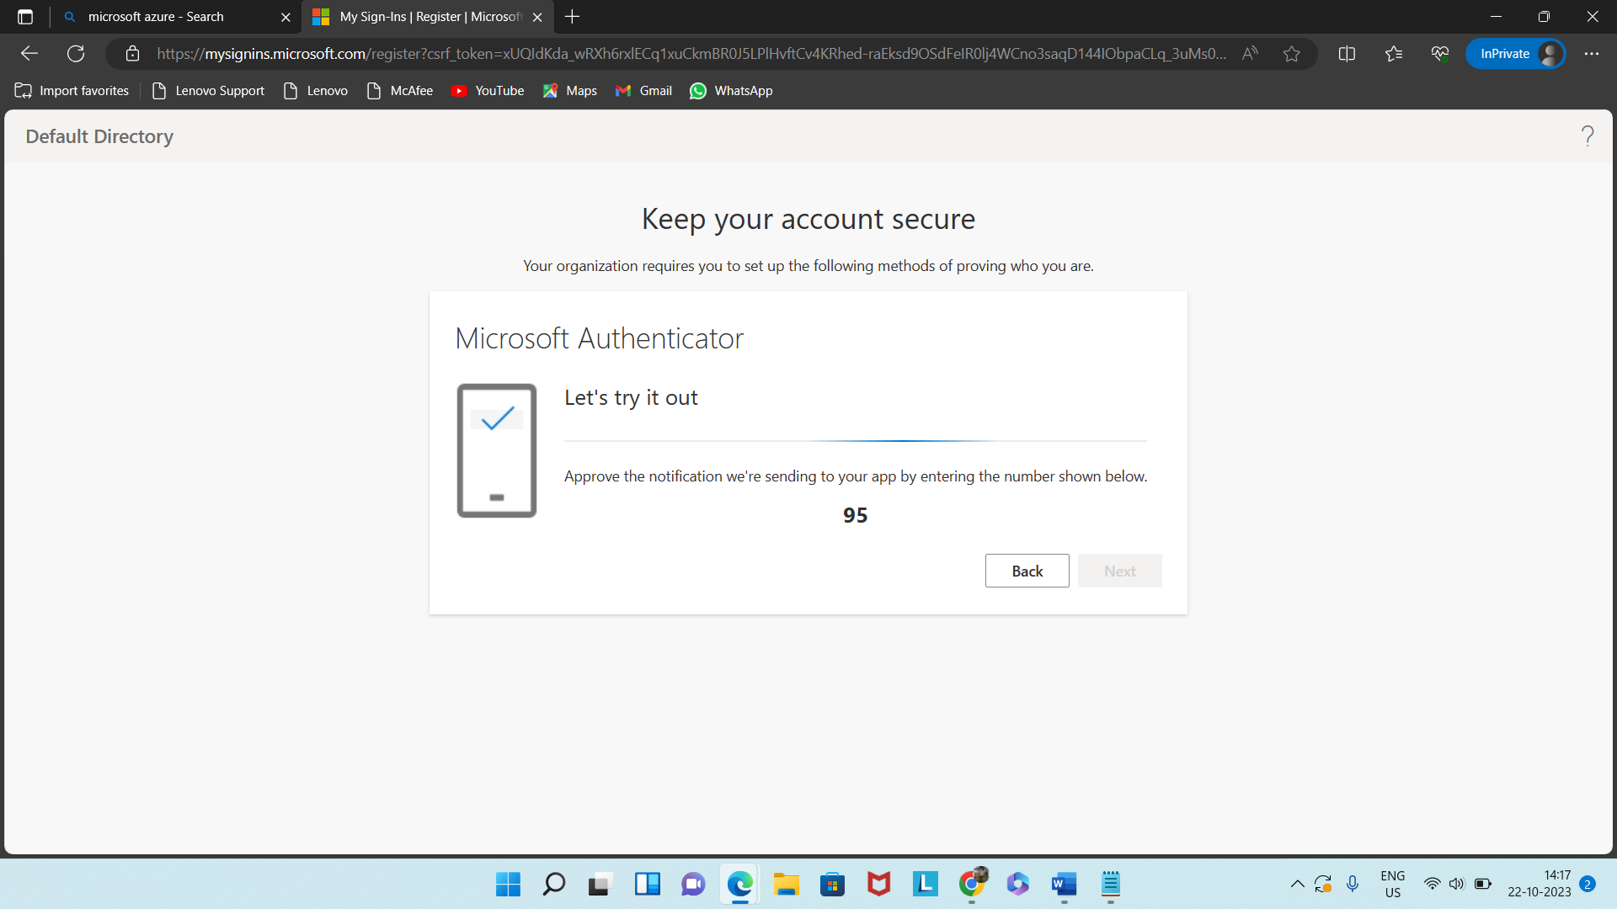

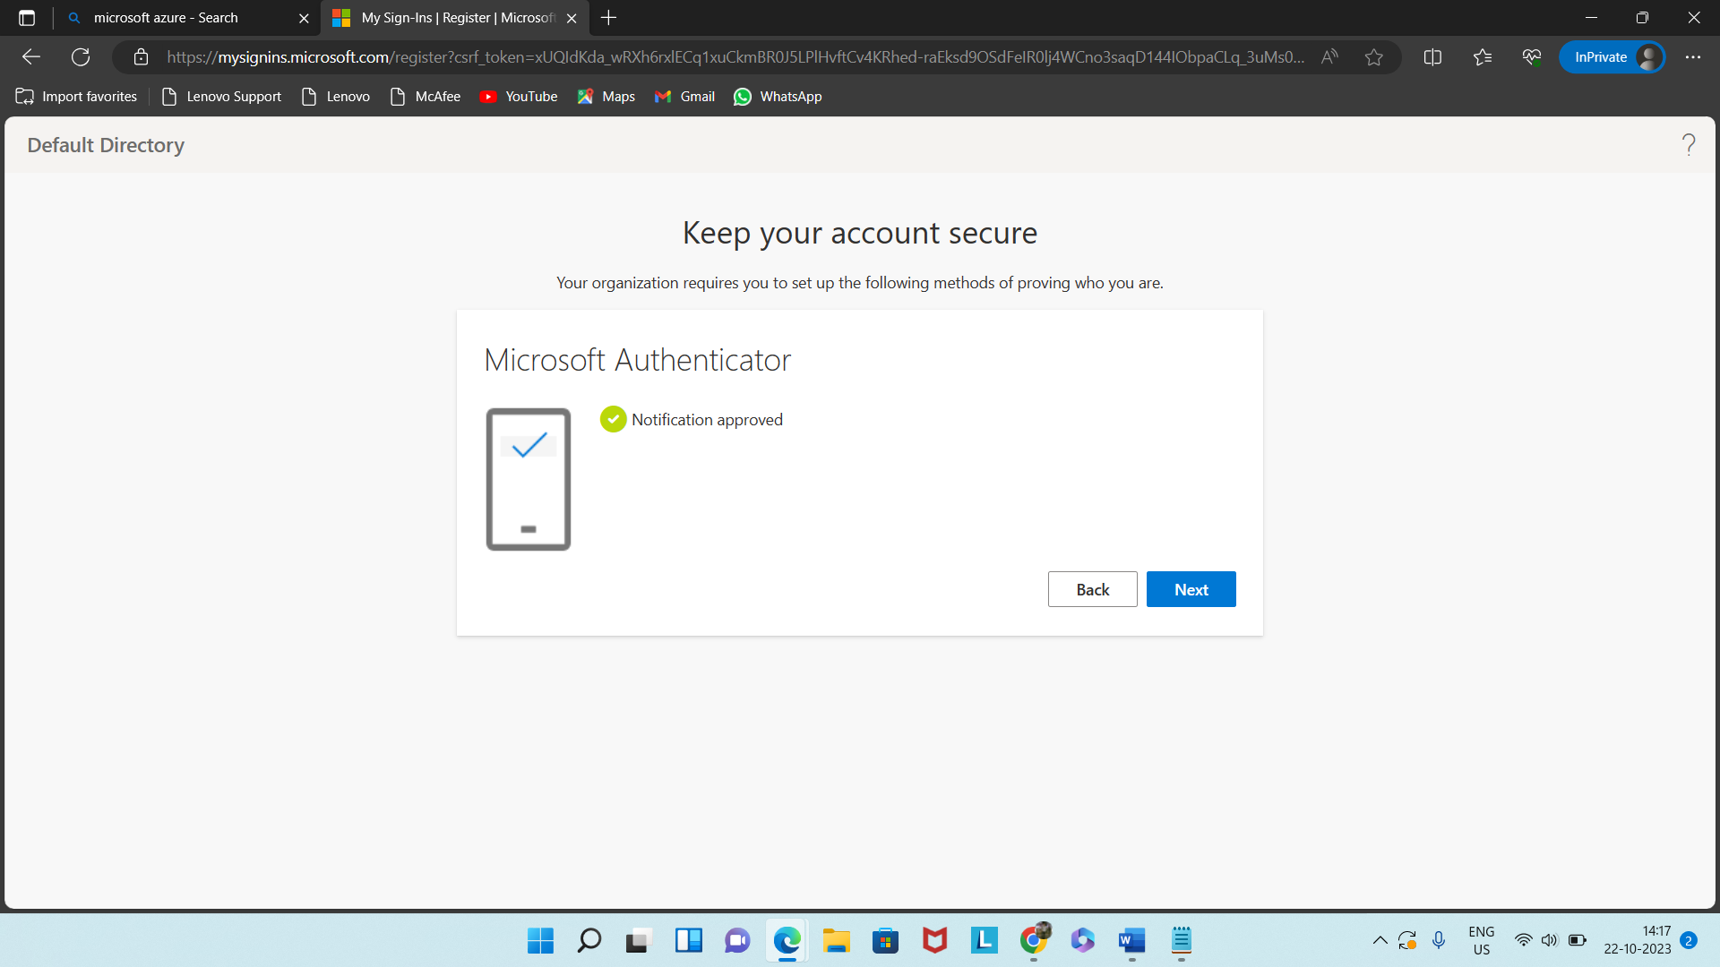

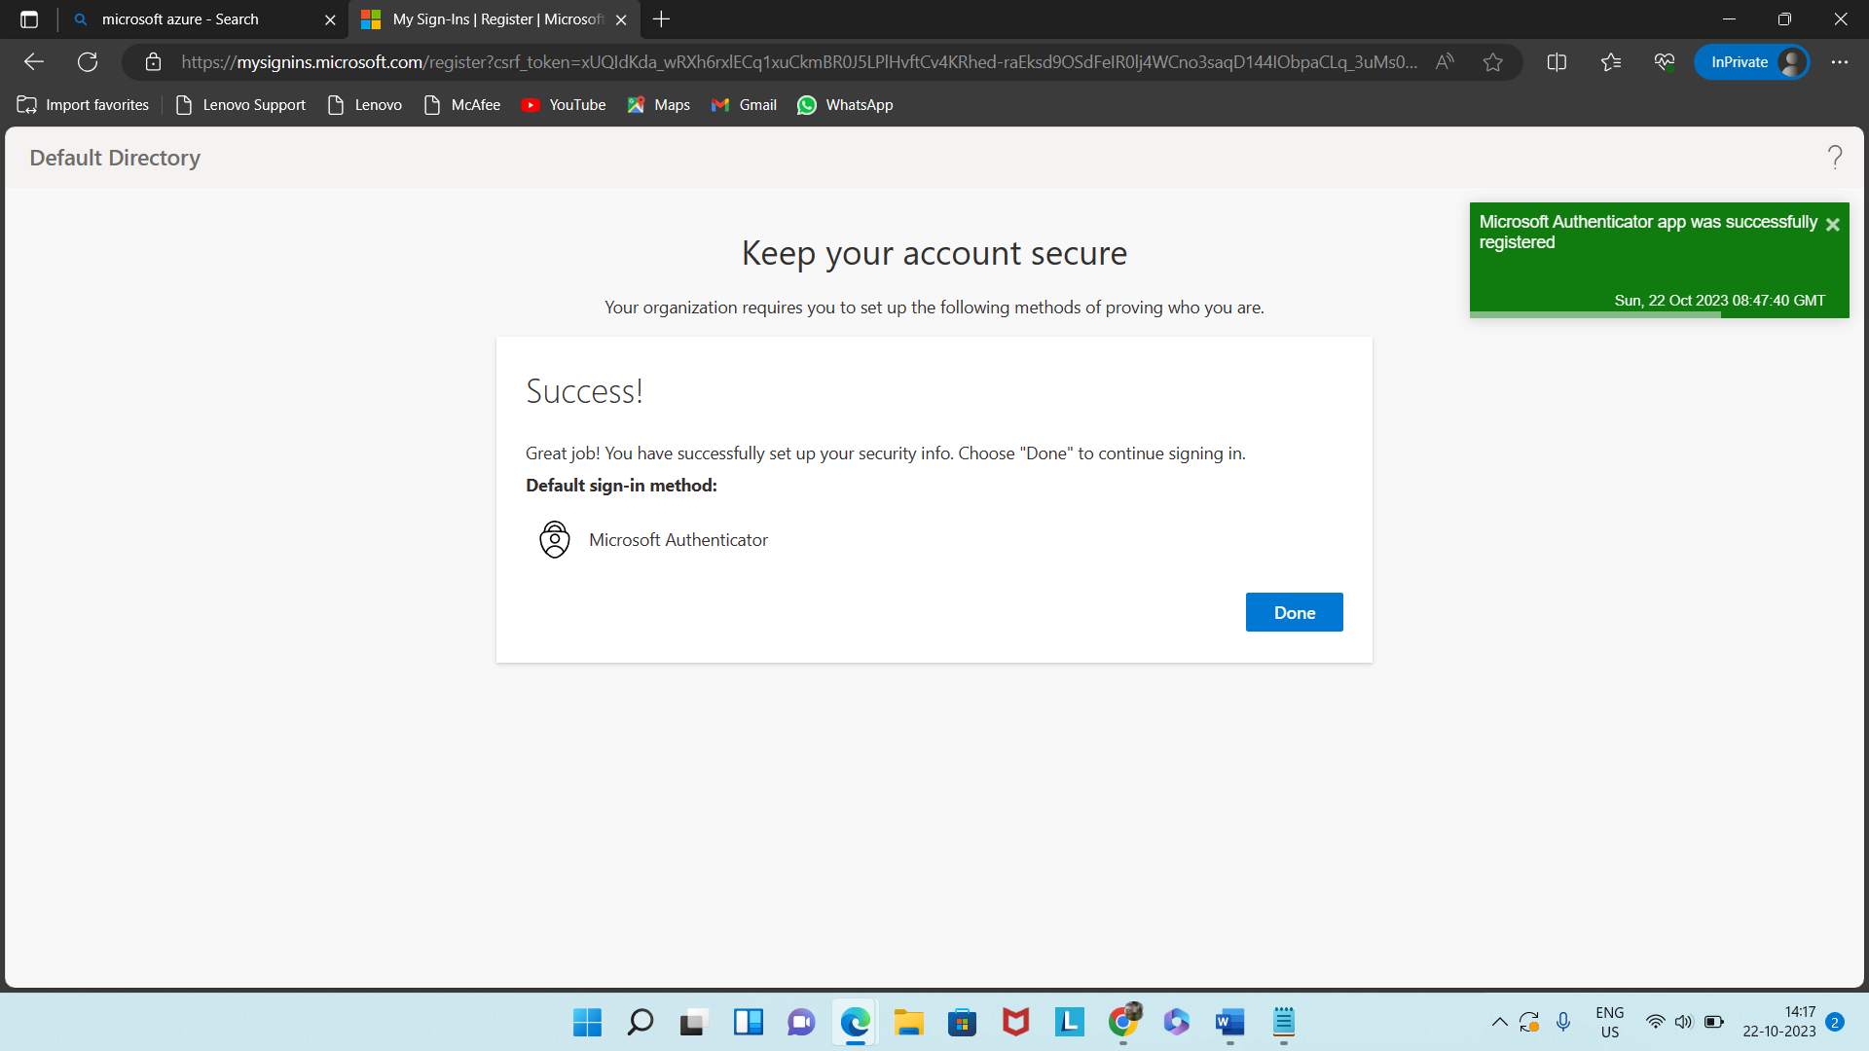

Reset the password.

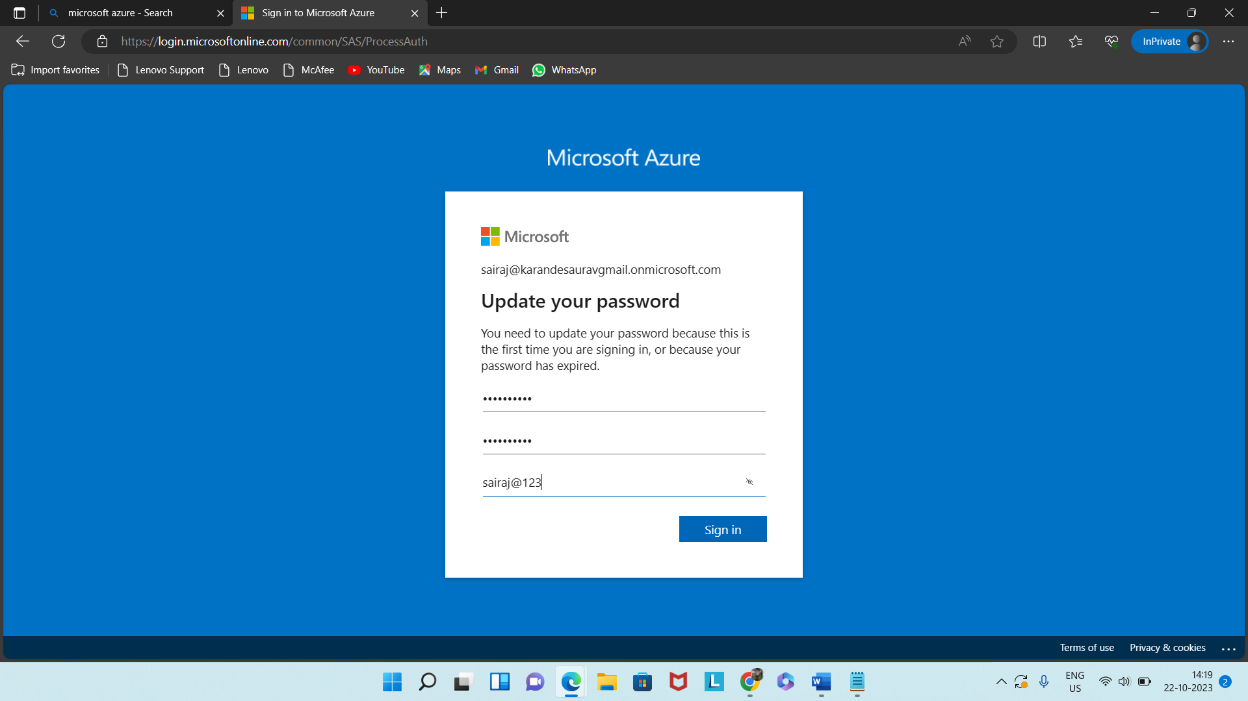

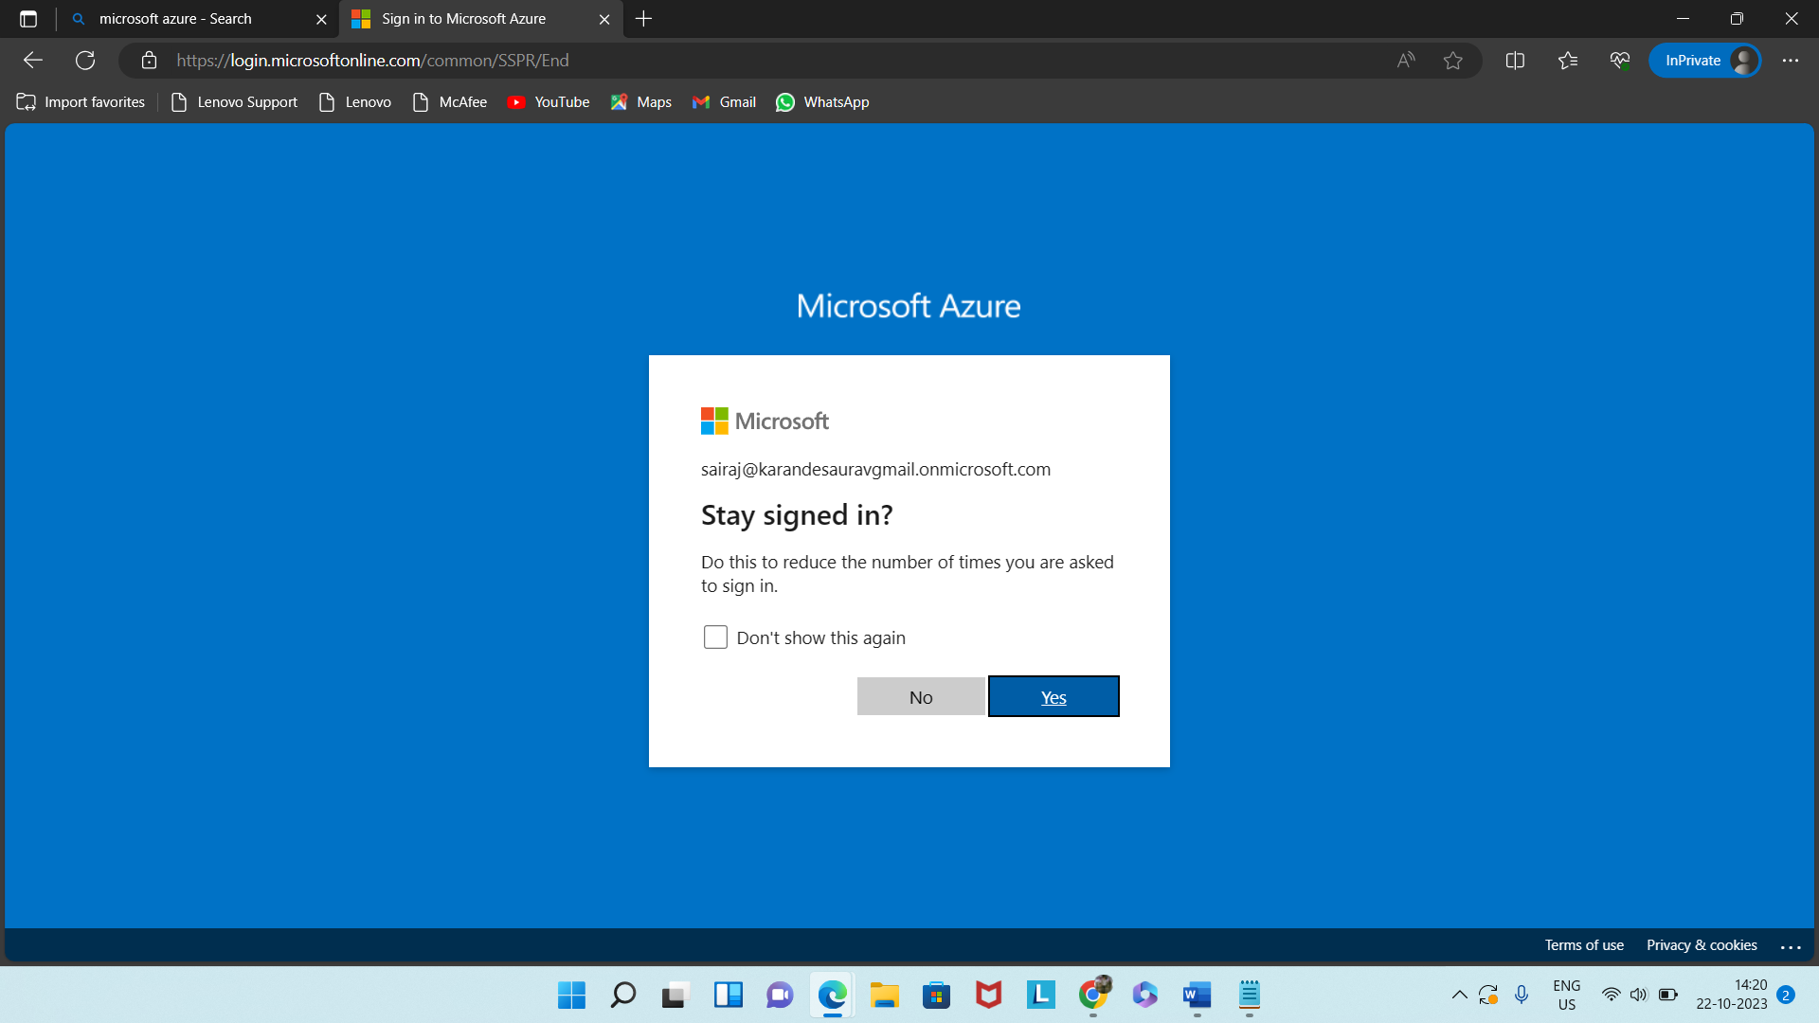

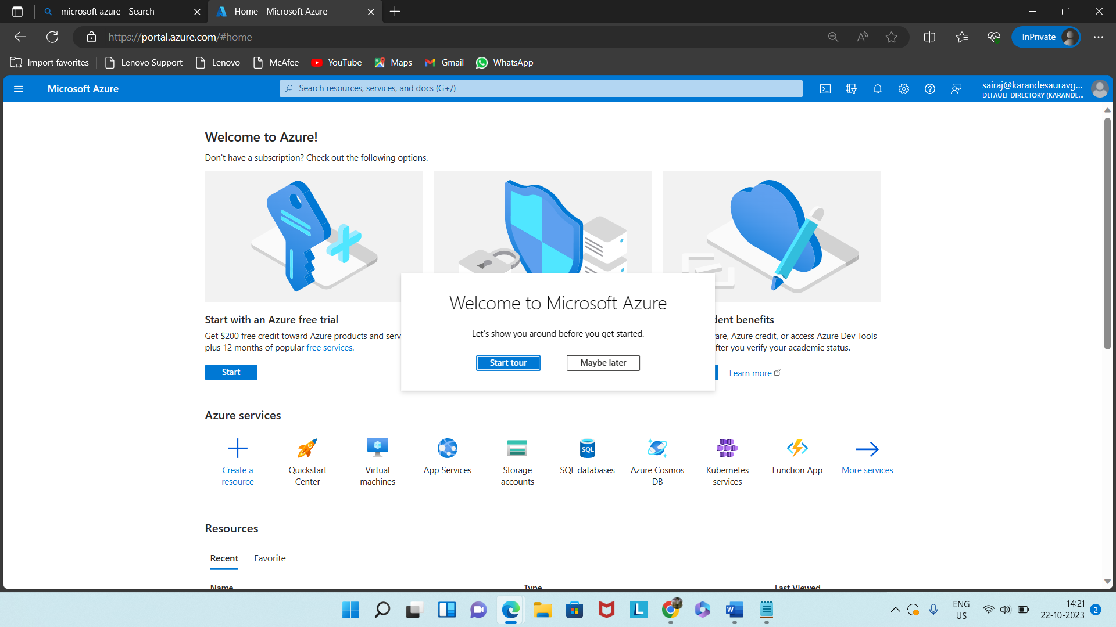

Now our multifactor authentication is enable